Math Test—Calculator
31 Questions

Turn to Section 4 of your answer sheet to answer the questions in this section.

Directions
For questions 1 through 27, solve each problem, choose the best answer from the choices provided, and indicate your answer choice on your answer sheet. For questions 28 through 31, solve the problem and indicate your answer, which is to be recorded in the spaces provided on the answer sheet. Please refer to the directions before question 28 on how to record your answers in the spaces provided. You may use scratch paper for scratch work.

Notes
1. The use of a calculator is permitted.
2. All variables and expressions used represent real numbers unless otherwise indicated.
3. Figures provided in this test are drawn to scale unless otherwise indicated.
4. All figures lie in a plane unless otherwise indicated.
5. Unless otherwise indicated, the domain of a given function f is the set of all real numbers x for which 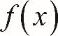 f of x is a real number.

Reference
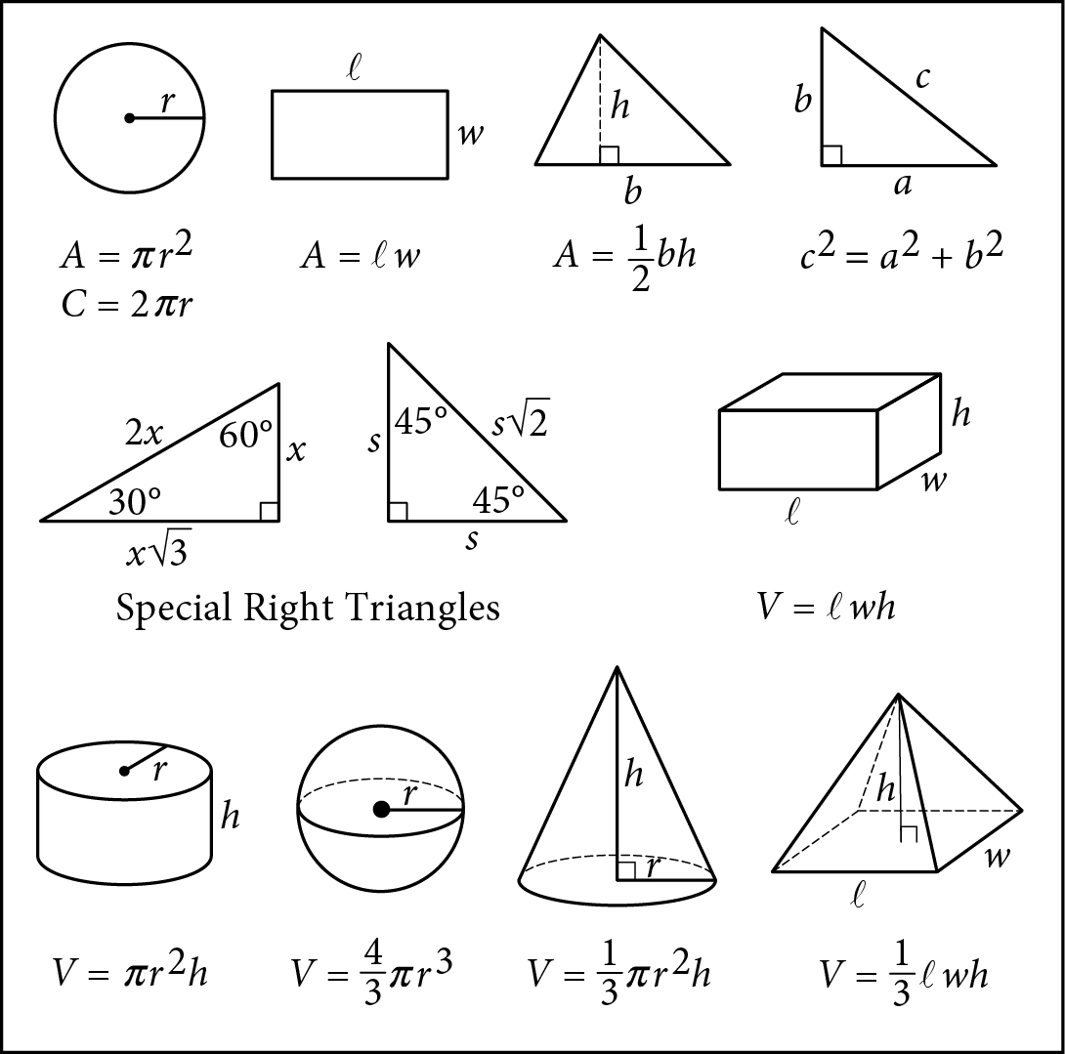

Begin skippable figure descriptions.
The figure presents information for your reference in solving some of the problems.

Reference figure 1 is a circle with radius r. Two equations are presented below reference figure 1.
A equals pi times the square of r.
C equals 2 pi r.

Reference figure 2 is a rectangle with length ℓ and width w. An equation is presented below reference figure 2.
A equals ℓ w.

Reference figure 3 is a triangle with base b and height h. An equation is presented below reference figure 3.
A equals one-half b h.

Reference figure 4 is a right triangle. The two sides that form the right angle are labeled a and b, and the side opposite the right angle is labeled c. An equation is presented below reference figure 4.
c squared equals a squared plus b squared.

Special Right Triangles
Reference figure 5 is a right triangle with a 30-degree angle and a 60-degree angle. The side opposite the 30-degree angle is labeled x. The side opposite the 60-degree angle is labeled x times the square root of 3. The side opposite the right angle is labeled 2 x.

Reference figure 6 is a right triangle with two 45-degree angles. Two sides are each labeled s. The side opposite the right angle is labeled s times the square root of 2.

Reference figure 7 is a rectangular solid whose base has length ℓ and width w and whose height is h. An equation is presented below reference figure 7.
V equals ℓ w h.

Reference figure 8 is a right circular cylinder whose base has radius r and whose height is h. An equation is presented below reference figure 8.
V equals pi times the square of r times h.

Reference figure 9 is a sphere with radius r. An equation is presented below reference figure 9.
V equals four-thirds pi times the cube of r.

Reference figure 10 is a cone whose base has radius r and whose height is h. An equation is presented below reference figure 10.
V equals one-third times pi times the square of r times h.

Reference figure 11 is an asymmetrical pyramid whose base has length ℓ and width w and whose height is h. An equation is presented below reference figure 11.
V equals one-third ℓ w h.

End skippable figure descriptions.

Additional Reference Information
The number of degrees of arc in a circle is 360.
The number of radians of arc in a circle is 2 pi.
The sum of the measures in degrees of the angles of a triangle is 180.

Question 1 refers to the following information.
A high school counselor conducted a study over 16 consecutive quarters to determine the number of students with part-time jobs. Each student in the 2014 graduating class is surveyed once per quarter for all four years of high school. The following graph shows the data for each quarter the survey was conducted.
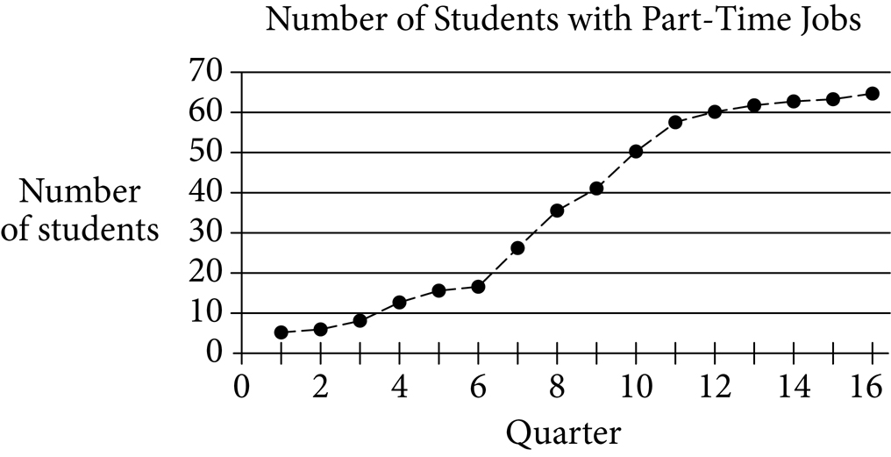

Begin skippable figure description.
The figure presents a line graph titled “Number of Students with Part-Time Jobs.” The horizontal axis is labeled “Quarter,” and the numbers 0 through 16, in increments of 2, are indicated. The vertical axis is labeled “Number of students,” and the numbers 0 through 70, in increments of 10, are indicated. There are 16 points on the graph, one for each quarter. The points are connected by a dashed line. The data represented by the points on the graph are as follows. Note that all values are approximate.

Point 1. 1 comma 5.
Point 2. 2 comma 6.
Point 3. 3 comma 8.
Point 4. 4 comma 13.
Point 5. 5 comma 16.
Point 6. 6 comma 17.
Point 7. 7 comma 26.
Point 8. 8 comma 35.
Point 9. 9 comma 41.
Point 10. 10 comma 50.
Point 11. 11 comma 58.
Point 12. 12 comma 60.
Point 13. 13 comma 61.
Point 14. 14 comma 62.
Point 15. 15 comma 63.
Point 16. 16 comma 65.

End skippable figure description.

Question 1.
During which of the following periods is the increase in the number of students with part-time jobs largest?
A. Quarters 4 through 6
B. Quarters 7 through 10
C. Quarters 11 through 14
D. Quarters 13 through 16

Question 2.
Eli saves money each month to buy a new computer. The total amount he has saved, T, can be calculated by the equation 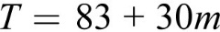 T equals 83 plus 30 m, where m is the number of months since he started saving. What does the number 83 represent in the equation?
A. The amount of money Eli started with
B. The number of months Eli has been saving
C. The amount of money Eli saves each month
D. The total amount of money Eli wants to save

Question 3.
According to the Department of Agriculture, consuming 100 grams of banana provides 0.15 milligram of zinc. Which of the following is closest to the number of milligrams of zinc provided by 140 grams of banana?
A. 0.15
B. 0.21
C. 0.25
D. 0.93

Question 4.
When the equation 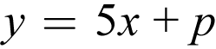 y equals 5 x plus p, where p is a constant, is graphed in the x y-plane, the line passes through the point 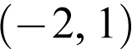 with coordinates negative 2 comma 1. What is the value of p ?
A. 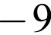 negative 9
B. 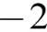 negative 2
C. 3
D. 11

Questions 5 and 6 refer to the following information.
The following scatterplot shows the number of hits and the number of times at bat by each of 20 players on a major league baseball team. The line of best fit for the data is also shown.
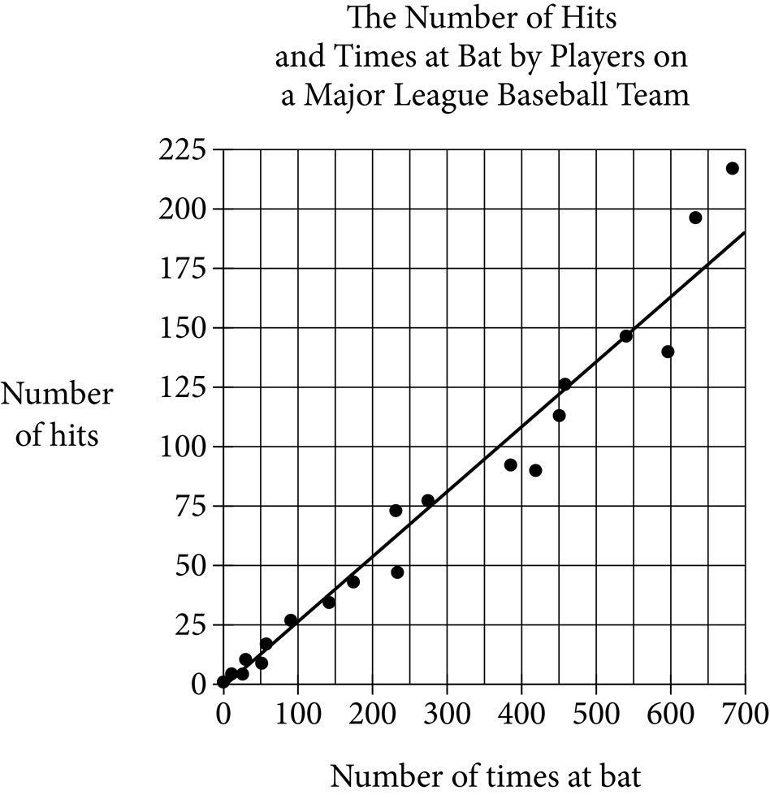

Begin skippable figure description.
The figure presents a scatterplot titled “The Number of Hits and Times at Bat by Players on a Major League Baseball Team.” The horizontal axis is labeled “Number of times at bat,” and the numbers 0 through 700, in increments of 100, are indicated. The vertical axis is labeled “Number of hits,” and the numbers 0 through 225, in increments of 25, are indicated. There are 20 data points in the scatterplot, and the line of best fit is drawn.

The data points begin at 1 comma 0 and extend upward and to the right, ending at approximately 680 comma 220. The line of best fit begins at 0 comma 0, and extends upward and to the right. The line passes through approximately 450 comma 122 and ends at 700 comma 190. Nine data points are below the line of best fit, one data point is on the line of best fit, and ten data points are above the line of best fit.

The data represented by the points are as follows. Note that all values are approximate.
Point 1. 1 comma 0.
Point 2. 10 comma 5.
Point 3. 25 comma 5.
Point 4. 30 comma 15.
Point 5. 50 comma 10.
Point 6. 60 comma 20.
Point 7. 90 comma 26.
Point 8. 143 comma 35.
Point 9. 175 comma 42.
Point 10. 233 comma 48.
Point 11. 230 comma 73.
Point 12. 275 comma 77.
Point 13. 385 comma 92.
Point 14. 420 comma 90.
Point 15. 450 comma 112.
Point 16. 460 comma 126.
Point 17. 540 comma 148.
Point 18. 598 comma 140.
Point 19. 630 comma 195.
Point 20. 680 comma 220.

End skippable figure description.

Question 5.
Which of the following statements about the relationship between the number of times at bat and the number of hits is true?
A. As the number of times at bat increases, the number of hits decreases.
B. As the number of times at bat increases, the number of hits increases.
C. As the number of times at bat increases, the number of hits remains constant.
D. As the number of times at bat decreases, the number of hits increases.

Question 6.
For the player with 450 times at bat, the actual number of hits the player had is approximately how many fewer than the number of hits predicted by the line of best fit?
A. 10
B. 20
C. 30
D. 40

Question 7.
An advertisement states that the printing rate of a certain printer is 400 characters per second. According to the convention that 1 word consists of 5 characters, what would be the advertised printing rate, in words per minute?
A. 2,000
B. 4,800
C. 24,000
D. 120,000

Question 8 refers to the following table.
Year | 0 | 1 | 2 | 3 | 4
Salary | 38,000 | 39,140 | 40,314 | 41,524 | 42,769

Question 8.
The preceding table shows the yearly salary, in dollars, of an employee at a company. Which of the following best describes the type of model that fits the data in the table?
A. Linear, increasing by approximately $1,140 per year
B. Linear, increasing by approximately $1,245 per year
C. Exponential, increasing by approximately 3% each year
D. Exponential, increasing by approximately 9% each year

Question 9 refers to the following expression.
open parenthesis, x squared, y, minus 3 y squared, plus 5 x, y squared, close parenthesis, minus, open parenthesis, negative x squared, y, plus 3 x, y squared, minus 3 y squared, close parenthesis

Question 9.
Which of the following is equivalent to the preceding expression?
A. 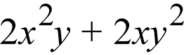 2 x squared, y, plus 2 x, y squared
B. 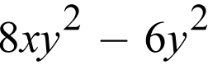 8 x, y squared, minus 6 y squared
C. 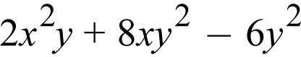 2 x squared, y, plus 8 x, y squared, minus 6 y squared
D. 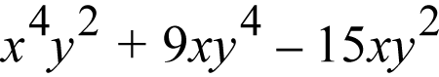 x to the power 4, end power, y squared, plus 9 x, y to the power 4, end power, minus 15 x, y squared

Question 10 refers to the following equation.
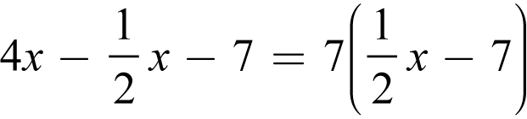
4 x minus one-half x minus 7, equals 7 times, open parenthesis, one-half x minus 7, close parenthesis

Question 10.
Which of the following describes the solution to the preceding equation?
A. x equals 0
B. 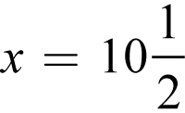 x equals 10 and one-half
C. The equation has infinitely many solutions.
D. The equation has no solutions.

Question 11 refers to the following information.
The following table shows the monthly electricity bills of Joseph and Samuel for the first five months of a year.
Electricity Bills
Month | Joseph | Samuel
January | $184.66 | $188.99
February | $193.12 | $181.27
March | $175.99 | $176.35
April | $145.30 | $149.23
May | $180.33 | $185.66

Question 11.
Based on the information in the table, which of these statements is true about the ranges and medians of the bills?
A. Both the range and median of Joseph’s bills are less than the range and median of Samuel’s bills.
B. Both the range and median of Joseph’s bills are greater than the range and median of Samuel’s bills.
C. The range of Joseph’s bills is less than the range of Samuel’s bills, while the median of Joseph’s bills is greater than the median of Samuel’s bills.
D. The range of Joseph’s bills is greater than the range of Samuel’s bills, while the median of Joseph’s bills is less than the median of Samuel’s bills.

Question 12 refers to the following table.
Cars in Service on a Railroad
 | In service less than 10 years | In service 10 or more years
Single level | 215 | 497
Double-decker | 16 | 82

Question 12.
The preceding table presents information about the 810 train cars in service on a railroad. Approximately what percentage of the train cars in service are double-decker cars that have been in service for less than 10 years?
A. 2 percent
B. 7 percent
C. 10 percent
D. 16 percent

Question 13.
A moving company uses plastic wrap to bundle groups of boxes together. If a portion of plastic wrap that measures 900 inches in length is used to bundle each group of boxes, how many groups of boxes can be bundled using 1,500 feet of the same type of plastic wrap?
A. 15
B. 20
C. 25
D. 30

Question 14 refers to the following information.
The following table shows the number of calories in a cheeseburger at six different restaurants.
Calories in a Cheeseburger
Restaurant | Calories
Blue Jay | 810
Clear Lake Cafe | 900
Molly’s | 740
Riverside Diner | 1,120
Maya’s Bistro | 1,050
Tom’s Place | 700

Question 14.
What is the difference in the number of calories in a cheeseburger at the Riverside Diner and the median number of calories in cheeseburgers at all six restaurants?
A. 190
B. 233
C. 265
D. 390

Question 15.
A circle is graphed in the x y-plane. If the circle has a radius of 3 and the center of the circle is at 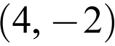 the point with coordinates 4 comma negative 2, which of the following could be an equation of the circle?
A. 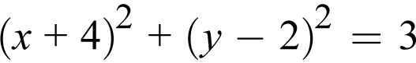 open parenthesis, x plus 4, close parenthesis, squared, plus, open parenthesis, y minus 2, close parenthesis, squared, equals 3
B. 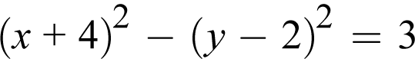 open parenthesis, x plus 4, close parenthesis, squared, minus, open parenthesis, y minus 2, close parenthesis, squared, equals 3
C. 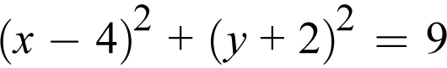 open parenthesis, x minus 4, close parenthesis, squared, plus, open parenthesis, y plus 2, close parenthesis, squared, equals 9
D. 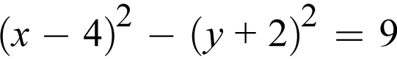 open parenthesis, x minus 4, close parenthesis, squared, minus, open parenthesis, y plus 2, close parenthesis, squared, equals 9

Questions 16 through 18 refer to the following information.
A high school developed a program called Propel, which offers extra guidance and support during the 9th-grade year. Before the school year began, 327 rising 9th graders were selected at random to participate in a study; 109 of those students were randomly assigned to enroll in the Propel program and the remaining students served as a control group. A summary of the year-end grade point averages (G P A) for the 327 9th-grade students who were chosen for the study is shown in the following table.
G P A for the 327 9th-Grade Students
G P A | Enrolled in Propel | Not enrolled in Propel
3.0 or greater | 61 | 95
Less than 3.0 | 48 | 123

Question 16.
If a 9th-grade student at the high school is chosen at random, which of the following is closest to the probability that the student will have a G P A of 3.0 or greater?
A. 0.64
B. 0.48
C. 0.33
D. 0.19

Question 17.
What is the difference, to the nearest whole percent, between the percentage of students enrolled in Propel who had a G P A of 3.0 or greater and the percentage of students not enrolled in Propel who had a G P A of 3.0 or greater?
A. 4%
B. 8%
C. 10%
D. 12%

Question 18.
Of the students enrolled in the Propel program, the ratio of boys to girls is approximately 2 to 3. Which of the following is the best estimate of the number of girls enrolled in the program?
A. 44
B. 65
C. 73
D. 131

Question 19.
An artist is creating a sculpture using bendable metal rods of equal length. One rod is formed into the shape of a square and another rod into the shape of an equilateral triangle. If each side of the triangle is 2 inches longer than each side of the square, how long, in inches, is each rod?
A. 16
B. 18
C. 24
D. 30

Question 20 refers to the following rational function.
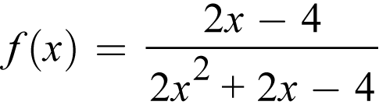
f of x, equals the fraction with numerator 2 x minus 4, and denominator 2 x squared, plus 2 x, minus 4, end fraction

Question 20.
Which of the following is an equivalent form of the preceding rational function that displays values not included in the domain as constants or coefficients?
A. 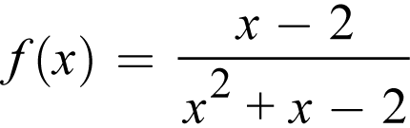 f of x, equals the fraction with numerator x minus 2, and denominator x squared, plus x, minus 2, end fraction
B. 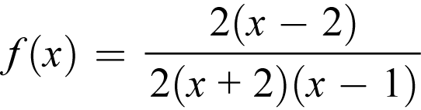 f of x, equals the fraction with numerator 2 times, open parenthesis, x minus 2, close parenthesis, and denominator 2 times, open parenthesis, x plus 2, close parenthesis, times, open parenthesis, x minus 1, close parenthesis, end fraction
C. 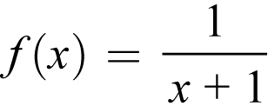 f of x, equals the fraction 1 over x plus 1, end fraction
D. 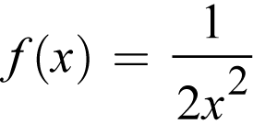 f of x, equals the fraction 1 over 2 x squared, end fraction

Question 21.
A landscaper is designing a rectangular fountain with a 4-foot-wide path around it. The equation 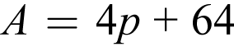 A, equals 4 p plus 64 will relate the area A, in square feet, of the path to the perimeter p, in feet, of the fountain. In the design, how many feet will the perimeter of the fountain increase for each additional square foot of the path’s area?
A. 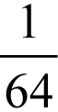 1 over 64
B. 1 over 4
C. 4
D. 64

Question 22.
In the x y-plane the graph of the function q is a parabola. The graph intersects the x-axis at 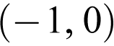 the point with coordinates negative 1 comma 0 and 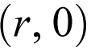 the point with coordinates r comma 0. If the vertex of q occurs at the point 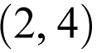 with coordinates 2 comma 4, what is the value of r ?
A. 0
B. 3
C. 4
D. 5

Question 23.
Liquid going through a cooling system is chilled so that its temperature decreases at a constant rate from 100 degrees Celsius to 25 degrees Celsius in 5 seconds. Which of the following functions represents the temperature C, in degrees Celsius, as a function of the time t, in seconds, after chilling began, for 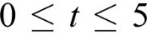 0 is less than or equal to t, which is less than or equal to 5?
A. C equals negative 25 plus 15 t
B. C equals 25 minus 15 t
C. C equals 25 plus 15 t
D. 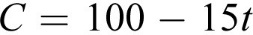 C equals 100 minus 15 t

Question 24 refers to the following formula.
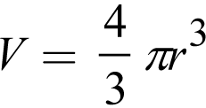 V equals four-thirds times, pi, r cubed

Question 24.
The preceding formula is for the volume of a sphere with radius r. The radius of the planet Jupiter is about 11 times the radius of planet Earth. Assuming that planets are spheres, about how many times larger is the volume of Jupiter than the volume of Earth?
A. 11
B. 121
C. 1,331
D. 1,775

Question 25.
The population of squirrels in a park has been doubling every 15 years. Which of the following statements describes the type of function that best models the relationship between the population of squirrels in the park and the number of 15-year time periods?
A. Exponential growth, because the population of squirrels is increasing by the same amount each 15-year time period
B. Exponential growth, because the population of squirrels is increasing by the same percentage each 15-year time period
C. Linear growth, because the population of squirrels is increasing by the same amount each 15-year time period
D. Linear growth, because the population of squirrels is increasing by the same percentage each 15-year time period

Question 26.
If function f is defined by 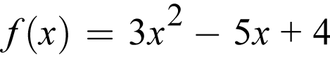 f of x equals 3 x squared, minus 5 x plus 4, what is 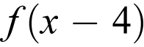 f of, open parenthesis, x minus 4, close parenthesis?
A. 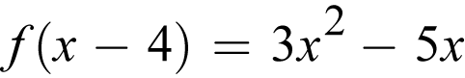 f of, open parenthesis, x minus 4, close parenthesis, equals 3 x squared minus 5 x
B. 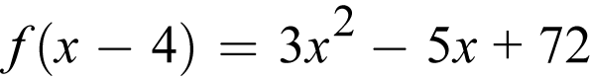 f of, open parenthesis, x minus 4, close parenthesis, equals 3 x squared, minus 5 x plus 72
C. 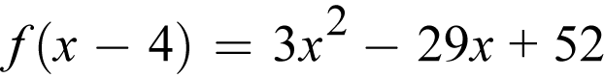 f of, open parenthesis, x minus 4, close parenthesis, equals 3 x squared, minus 29 x plus 52
D. 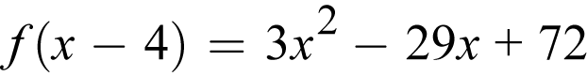 f of, open parenthesis, x minus 4, close parenthesis, equals 3 x squared, minus 29 x plus 72

Question 27 refers to the following equations of two lines.
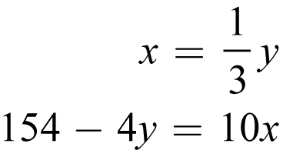
x equals one-third y; and,
154 minus 4 y equals 10 x

Question 27.
If the lines are graphed in the x y-plane, which of the following ordered pairs represents the point at which the lines would intersect?
A. 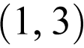 1 comma 3
B. 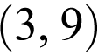 3 comma 9
C. 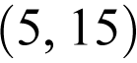 5 comma 15
D. 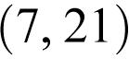 7 comma 21

Directions
For questions 28 through 31, solve the problem and record your answer in the spaces provided on the answer sheet, as described in the following directions and examples.

1. Although not required, it is suggested that your answer be recorded in the boxes at the top of the columns to help fill in the circles accurately. You will receive credit only if the circles are filled in correctly.
2. Mark no more than one circle in any column.
3. No question has a negative answer.
4. Some problems may have more than one correct answer. In such cases, indicate only one answer.
5. Mixed numbers such as 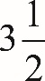 three and one half must be recorded as 3.5 or seven slash two. (If 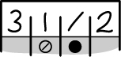 three, one, slash, two, is recorded in the spaces provided on the answer sheet, it will be interpreted as 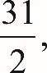 thirty one halves, not 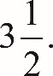 three and one half.)
6. Decimal answers: If you obtain a decimal answer with more digits than the spaces on the answer sheet can accommodate, it may be either rounded or truncated, but it must fill all four spaces.

The following are four examples of how to record your answer in the spaces provided. Keep in mind that there are four spaces provided to record each answer.

Examples 1 and 2
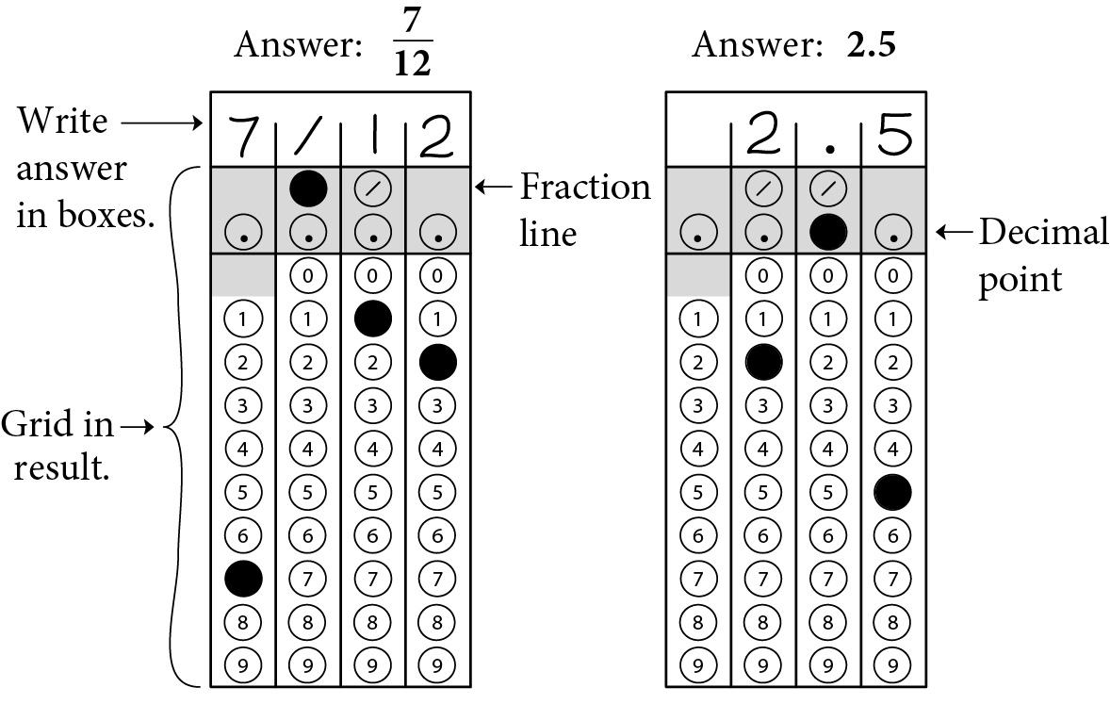

Begin skippable figure description.
Example 1: If your answer is a fraction such as seven-twelfths, it should be recorded as follows. Enter 7 in the first space, the fraction bar (a slash) in the second space, 1 in the third space, and 2 in the fourth space. All four spaces would be used in this example.

Example 2: If your answer is a decimal value such as 2.5, it could be recorded as follows. Enter 2 in the second space, the decimal point in the third space, and 5 in the fourth space. Only three spaces would be used in this example.

End skippable figure description.

Example 3
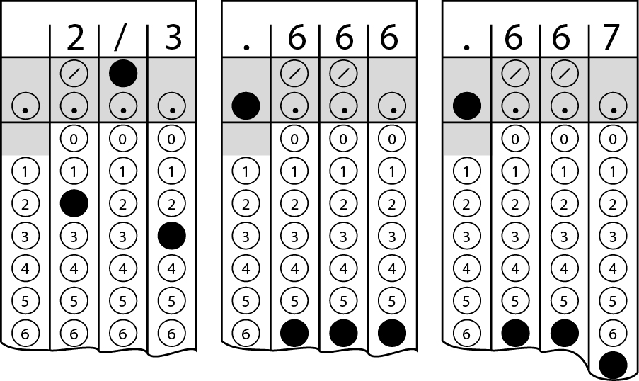

Begin skippable figure description.
Example 3: Acceptable ways to record two-thirds are: 2 slash 3, .666, and .667.

End skippable figure description.

Example 4
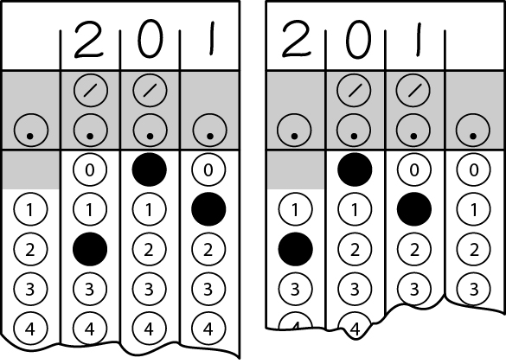
Note: You may start your answers in any column, space permitting. Columns you don’t need to use should be left blank.

Begin skippable figure description.
Example 4: It is not necessary to begin recording answers in the first space unless all four spaces are needed. For example, if your answer is 201, you may record 2 in the second space, 0 in the third space, and 1 in the fourth space. Alternatively, you may record 2 in the first space, 0 in the second space, and 1 in the third space. Spaces not needed should be left blank.

End skippable figure description.

Question 28 refers to the following table.
Type of meal | Fat (grams) | Carbohydrates (grams)
Stir-fry | 4 | 40
Szechuan chicken | 5 | 35

Question 28.
A grocer carries two types of frozen meals that have the fat and carbohydrate content shown in the preceding table. John wants to purchase a combination of the two types of meals with no more than 350 grams of fat and no more than 2975 grams of carbohydrates. If John purchases 10 Szechuan chicken meals, what is the greatest number of stir-fry meals he can purchase so that the combination will satisfy the requirements?

Question 29 refers to the following system of equations.
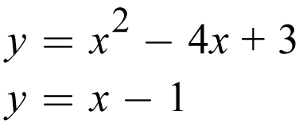
y equals x squared, minus 4 x plus 3; and,
y equals x minus 1

Question 29.
If 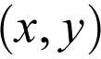 the ordered pair x comma y is a solution to the preceding system of equations, what is one possible value of the product of x and y ?

Questions 30 and 31 refer to the following information.
The following graph shows the supply, in millions of pounds, of king crab harvested and sold from 2005 to 2011. The information for the year 2012 is not included in the graph.

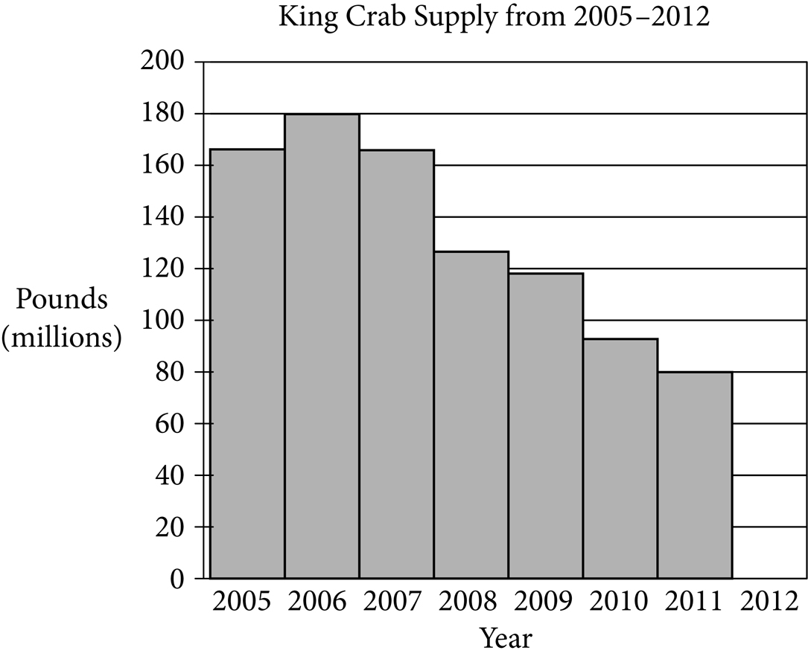

Begin skippable figure description.
The figure presents a histogram titled “King Crab Supply from 2005 through 2012.” The horizontal axis is labeled “Year,” and the years 2005 through 2012 are indicated. The vertical axis is labeled “Pounds, in millions,” and the numbers 0 through 200, in increments of 20, are indicated. The data represented by the bars are as follows. Note that all values are approximate.

2005, 165 million pounds.
2006, 180 million pounds.
2007, 165 million pounds.
2008, 125 million pounds.
2009, 118 million pounds.
2010, 95 million pounds.
2011, 80 million pounds.
2012, no bar shown.

End skippable figure description.

Question 30.
In 2006, the price of king crab was $8 per pound at the beginning of the year and dropped to $7 per pound toward the end of the year. If 60% of the king crab supply was sold at the higher price per pound and the rest was sold at the lower price per pound, what was the total revenue generated, in millions of dollars, from the sales of king crab in 2006 ? (Disregard the dollar sign when indicating your answer.)

Question 31.
In 2011, the price of king crab was $17 per pound. In 2012, x million pounds of king crab were sold at $16 per pound. If the total money generated from sales each year was the same, what is the value of x ?

Stop.
If you finish before time is called, you may check your work on this section only. Do not go on to any other section.

P S A T™ 10
Assistive Technology Compatible Test Form

Answers and explanations

For section 4, Math Test—Calculator

Explanation for question 1.
Correct answer
Choice B is correct. Looking at the graph, it can be concluded that there is an increase of fewer than 10 students during quarters 4 through 6, quarters 11 through 14, and quarters 13 through 16. There is an increase of more than 20 students during quarters 7 through 10. Therefore, of the four ranges given in the answer choices, the greatest increase in the number of students occurs during quarters 7 through 10.
Incorrect answer
Choices A, C, and D are incorrect. There is an increase of fewer than 10 students during quarters 4 through 6, quarters 11 through 14, and quarters 13 through 16. There is an increase of more than 20 students during quarters 7 through 10. Therefore, the greatest increase in the number of students does not occur in the ranges given in choices A, C, and D.

Explanation for question 2.
Correct answer
Choice A is correct. The time at which Eli began saving corresponds to m equals 0. Therefore, the value of T when m equals 0 represents the amount of money Eli started with. Substituting 0 for m gives 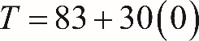 T equals 83 plus 30 times 0, or T equals 83. Therefore, the amount of money Eli started with is 83 units of money. (Note: The item does not specify a unit of money, such as dollars; however, this does not change the interpretation of the number 83 in the equation.)
Incorrect answer
Choice B is incorrect because the number of months Eli has been saving corresponds to the value of m. Choice C is incorrect because the amount of money Eli saves each month is 30 units of money. Choice D is incorrect because the amount of money Eli wants to save is not provided in the problem.

Explanation for question 3.
Correct answer
Choice B is correct. Since 0.15 milligrams of zinc is provided by 100 grams of banana, the number of milligrams of zinc provided by 140 grams of banana can be found by solving for x in the proportion 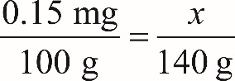 0.15 milligrams over 100 grams, equals x over 140 grams. Cross-multiplying gives 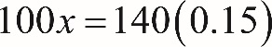 100 x equals 140 times 0.15, or 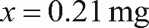 x equals 0.21 milligrams.
Incorrect answer
Choice A is incorrect because 0.15 milligrams is the amount of zinc in 100 grams of banana, not in 140 grams. Choices C and D are incorrect and likely the result of calculation errors.

Explanation for question 4.
Correct answer
Choice D is correct. In the x y-plane, the point 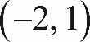 with coordinates negative 2 comma 1, is the point where x equals negative 2 and 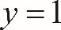 y equals 1. Because the point with coordinates negative 2 comma 1 is on the line, we can substitute x equals negative 2 and y equals 1 into the equation for the line. This substitution yields 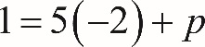 1 equals 5 times negative 2, plus p, or 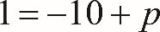 1 equals negative 10 plus p. Solving this equation for p gives 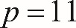 p equals 11.
Incorrect answer
Choice A is incorrect and likely arises by subtracting 10 from both sides of the equation 1 equals 5 times negative 2, plus p rather than by adding 10. Choice B is incorrect and likely arises from mistakenly equating the value of p with the x-coordinate of the given point. Choice C is incorrect and likely the result of calculation errors.

Explanation for question 5.
Correct answer
Choice B is correct. The line of best fit shown for the data has a positive slope. It can be concluded from this that higher values for the number of times at bat correspond to higher values for the number of hits. Therefore, as the number of times at bat increases, the number of hits increases.
Incorrect answer
Choice A is incorrect because the number of hits increases, not decreases, as the number of times at bat increases. Choice C is incorrect because the number of hits increases as the number of times at bat increases. Choice D is incorrect because as the number of times at bat decreases, the number of hits decreases, not increases.

Explanation for question 6.
Correct answer
Choice A is correct. According to the scatterplot, the player with 450 times at bat had approximately 113 hits (the y-coordinate of the point representing this player is approximately halfway between 100 and 125). The line of best fit predicts approximately 123 hits. Therefore, the actual number of hits made by this player is approximately 10 fewer than the number of hits predicted by the line of best fit.
Incorrect answer
Choices B, C, and D are incorrect because each gives a value much greater than 10, which is the best approximation of how many fewer hits were made by the player with 450 times at bat than predicted by the line of best fit.

Explanation for question 7.
Correct answer
Choice B is correct. Since the printer can print 400 characters per second and there are 60 seconds in each minute, the printer can print 400 times 60, or 24,000, characters per minute. Using the convention of 5 characters per word, the printer can print 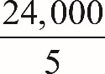 the fraction 24,000 over 5, or 4,800, words per minute.
Incorrect answer
Choice A is incorrect; it is the result of multiplying 400 characters per second by 5 characters per word. Choice C is incorrect because it is the number of characters that can be printed each minute, not the number of 5-character words that can be printed each minute. Choice D is the result of multiplying, rather than dividing, the 24,000 characters the printer can print each minute by 5 characters per word.

Explanation for question 8.
Correct answer
Choice C is correct. From Year 0 to Year 1, the salary increases by $1,140; from Year 1 to Year 2, the salary increases by $1,174; from Year 2 to Year 3, the salary increases by $1,210; and from Year 3 to Year 4, the salary increases by $1,245. Because the dollar amount of the salary increases each year at a nonconstant rate, a linear model will not be a good fit to the data. However, the ratio of the salary in a certain year to the salary in the preceding year remains about the same from one year to the next. For example, the ratio of the salary in Year 1 to the salary in Year 0 is 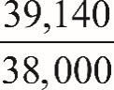 the fraction 39,140 over 38,000, and the ratio of the salary in Year 2 to the salary in Year 1 is 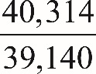 the fraction 40,314 over 39,140. Both these ratios are approximately 1.03, which corresponds to a 3% increase each year. Therefore, an exponential model increasing by approximately 3% each year would describe the data better than the models in the other choices.
Incorrect answer
Choices A and B are incorrect because they suggest a linear model is most appropriate; in a linear model, the dollar amount of the salary increase would be approximately the same from one year to the next. In this example, the dollar amount of the salary increase is increasing each year, so a linear model wouldn’t fit the data well. Choice D is incorrect because the ratio of the salary in a certain year to the salary in the preceding year (for example, the fraction 40,314 over 39,140 and the fraction 39,140 over 38,000) is approximately 1.03, which corresponds to a 3% increase each year, not a 9% increase each year.

Explanation for question 9.
Correct answer
Choice A is correct. Distributing the factor of negative 1 through the second expression in parentheses in open parenthesis, x squared y, minus 3 y squared, plus 5 x y squared, close parenthesis, minus, open parenthesis, negative x squared y, plus 3 x y squared, minus 3 y squared, close parenthesis, yields x squared y, minus 3 y squared, plus 5 x y squared, plus x squared y, minus 3 x y squared, plus 3 y squared. Regrouping by like terms, the expression becomes open parenthesis, x squared y, plus x squared y, close parenthesis, plus, open parenthesis, negative 3 y squared, plus 3 y squared, close parenthesis, plus, open parenthesis, 5 x y squared, minus 3 x y squared, close parenthesis, which simplifies to 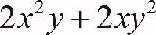 2 x squared y, plus 2 x y squared.
Incorrect answer
Choice B is incorrect; it is the result of adding, rather than subtracting, the given expressions 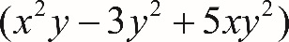 open parenthesis, x squared y, minus 3 y squared, plus 5 x y squared, close parenthesis, and 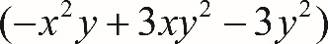 open parenthesis, negative x squared y, plus 3 x y squared, minus 3 y squared, close parenthesis. Choice C is incorrect; it is the result of subtracting only the first term in the second expression from the first expression and adding the other terms in the second expression to the first expression. Choice D is the result of attempting to multiply the first, second, and third terms in each of the two expressions rather than subtracting.

Explanation for question 10.
Correct answer
Choice D is correct. The equation 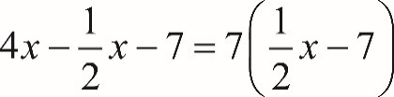 4 x, minus one-half x, minus 7 equals, 7 times, open parenthesis, one-half x minus 7, close parenthesis can be rewritten as 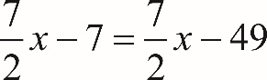 seven-halves x, minus 7 equals, seven-halves x, minus 49, which results in the equation 7 equals 49. Because 7 is not equal to 49, there is no value of x that makes the equation true. Therefore, there are no solutions to this equation.
Incorrect answer
Choice A is incorrect. It may be the result of substituting 0 for x in the given equation and incorrectly applying the distributive property on the right side of the equation, yielding negative 7 equals negative 7. Choice C is incorrect and may result from incorrectly distributing the 7 on the right-hand side of the equation to obtain 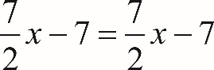 seven-halves x, minus 7 equals, seven-halves x, minus 7; this equation has infinitely many solutions. Choice B is incorrect and likely results from errors made when simplifying the left- and right-hand sides of the equation when solving for x.

Explanation for question 11.
Correct answer
Choice D is correct. The range of Joseph’s bills is 193 dollars and 12 cents minus 145 dollars and 30 cents equals 47 dollars and 82 cents, which is greater than the range of Samuel’s bills, which is 188 dollars and 99 cents minus 149 dollars and 23 cents equals 39 dollars and 76 cents. The median of Joseph’s bills is 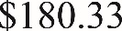 180 dollars and 33 cents, which is less than the median of Samuel’s bills, 181 dollars and 27 cents.
Incorrect answer
Choices A, B, and C are incorrect. The range of Joseph’s bills is greater than the range of Samuel’s bills, and the median of Joseph’s bills is less than the median of Samuel’s bills. Each of choices A, B, and C gets at least one of these facts wrong.

Explanation for question 12.
Correct answer
Choice A is correct. According to the table, there are 16 double-decker train cars that have been in service for less than 10 years. Since there are 810 train cars in service on the railroad, the portion of the train cars that are double-decker train cars that have been in service for less than 10 years is 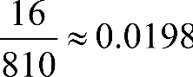 the fraction 16 over 810 is approximately equal to 0.0198. This corresponds to 1.98%, or about 2%.
Incorrect answer
Choice B is incorrect and may be the result of dividing 16 by 215, which gives the ratio of the number of double-decker train cars that have been in service less than 10 years to the number of single-level train cars that have been in service less than 10 years, and then multiplying by 100. Choice C is incorrect and may be the result of using the number of double-decker train cars that have been in service for more than 10 years, 82, rather than using the number of double-decker train cars that have been in service for less than 10 years, 16. Choice D is incorrect and may be the result of identifying that there are 16 double-decker cars that have been in service for less than 10 years and assuming that the answer is 16%, rather than dividing 16 by the total number of train cars in service to find the actual percentage.

Explanation for question 13.
Correct answer
Choice B is correct. There are 12 inches in one foot, so the 900 inches of plastic wrap used for each group of boxes is equal to 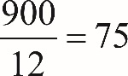 the fraction 900 over 12 equals 75 feet. The total number of groups of boxes that can be bundled with 1,500 feet of plastic wrap can be found by dividing the total number of feet of plastic wrap, 1,500, by the number of feet of plastic wrap needed for each group, 75. Therefore, 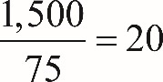 the fraction 1,500 over 75 equals 20 groups of boxes can be bundled with 1,500 feet of plastic wrap.
Incorrect answer
Choice A is incorrect because more than 15 groups of boxes can be bundled with 1,500 feet of plastic wrap. If 900 inches of plastic wrap are needed per group, then the amount of plastic wrap needed to bundle 15 groups is 1,125 feet 900 inches times 15 groups equals 13,500 inches; 13,500 inches divided by 12 inches per foot equals 1,125 feet). The problem states that there are 1,500 feet of plastic wrap available. Choices C and D are incorrect because there is not enough plastic wrap to bundle this many groups of boxes. To bundle 25 groups, 1,875 feet of plastic wrap are needed 900 inches times 25 groups equals 22,500 inches; 22,500 inches divided by 12 inches per foot equals 1,875 feet). To bundle 30 groups, 2,250 feet of plastic wrap are needed 900 inches times 30 groups equals 27,000 inches; 27,000 inches divided by 12 inches per foot equals 2,250 feet).

Explanation for question 14.
Correct answer
Choice C is correct. The number of calories listed in the table can be ordered from least to greatest, as follows: 700, 740, 810, 900, 1,050, and 1,120. Since the total of numbers in the list, 6, is an even number, the median is the mean of the two middle numbers, 810 and 900, which is 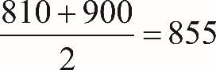 the fraction with numerator 810 plus 900 and denominator 2, equals 855. According to the table, the cheeseburger at the Riverside Diner has 1,120 calories. Therefore, the difference in the number of calories in a cheeseburger at the Riverside Diner and the median number of calories in cheeseburgers at all six restaurants is 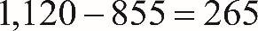 1,120 minus 855 equals 265.
Incorrect answer
Choice A is incorrect. This answer choice is the result of incorrectly finding the median by using the mean of the two middle numbers, 740 and 1,120, in the table’s unsorted list of the number of calories in cheeseburgers. Choice B is incorrect. This answer choice is the approximate difference between the number of calories in a cheeseburger at the Riverside Diner and the mean (rather than the median) number of calories in the cheeseburgers at all six restaurants. Choice D is incorrect. This answer choice may be the result of assuming that the median is the third number listed in the table, finding the difference between the number of calories in a cheeseburger at the Riverside Diner and the number of calories in a cheeseburger at Molly’s 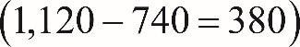 (1,120 minus 740 equals 380), and then selecting the closest available value, 390.

Explanation for question 15.
Correct answer
Choice C is correct. The standard form for the equation of a circle in the x y-plane with center 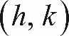 with coordinates h comma k and radius r is 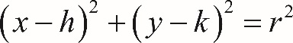 open parenthesis, x minus h, close parenthesis, squared, plus, open parenthesis, y minus k, close parenthesis, squared, equals r squared. Therefore, the equation of a circle with radius 3 and center 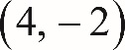 with coordinates 4 comma negative 2 is 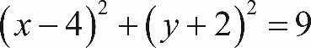 open parenthesis, x minus 4, close parenthesis, squared, plus, open parenthesis, y plus 2, close parenthesis, squared, equals 9.
Incorrect answer
Choice A is incorrect. This equation is of a circle with center at 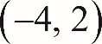 the point with coordinates negative 4 comma 2 and a radius of 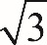 square root of 3, not 3. Choices B and D are incorrect because these equations define ellipses rather than circles; in the standard form for an equation of a circle, the two squared terms on the left-hand side of the equation are added, not subtracted.

Explanation for question 16.
Correct answer
Choice B is correct. Since the 327 ninth-grade students are a random sample selected from all ninth-grade students in the school, the sample can be considered to be representative of all the ninth-grade students in the school. This means that the proportion of ninth-grade students in the school who had a G P A of 3.0 or greater can be estimated using the proportion of ninth-grade students who had a G P A of 3.0 or greater in the sample. Of the 327 ninth-grade students in the study, 61 plus 95 equals 156 students had a G P A of 3.0 or greater. Therefore, the probability that a ninth-grade student at the school chosen at random had a G P A of 3.0 or greater is estimated to be 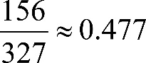 the fraction 156 over 327 which is approximately equal to 0.477, which rounds to 0.48.
Incorrect answer
Choice A is incorrect. This answer choice is the result of dividing the number of students in the study enrolled in Propel with a G P A of 3.0 or greater, 61, by the number of students in the study not enrolled in Propel with a G P A of 3.0 or greater, 95, rather than dividing the total number of students with a G P A of 3.0 or higher by the total number of students in the study. Choice C is incorrect. This answer choice reflects the probability that a ninth-grade student, selected at random, is enrolled in Propel. It is the result of dividing the total number of students enrolled in Propel, rather than the total number of students with a G P A of 3.0 or greater, by the total number of students in the study. Choice D is incorrect. This answer choice reflects the probability that a ninth-grade student, selected at random, is enrolled in Propel and has a G P A of 3.0 or greater. It is the result of dividing the number of students who both are enrolled in Propel and had a G P A of 3.0 or greater, rather than all students who had a G P A of 3.0 or greater, by the total number of students in the study.

Explanation for question 17.
Correct answer
Choice D is correct. There are 61 students enrolled in Propel who had a G P A of 3.0 or greater and 48 students enrolled in Propel who had a G P A of less than 3.0, so there are a total of 61 plus 48 equals 109 students enrolled in Propel. The percentage of students enrolled in Propel who had a G P A of 3.0 or greater is 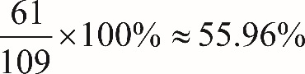 the fraction 61 over 109 times 100 percent is approximately equal to 55.96, or about 56%. There are 95 students who are not enrolled in Propel who had a G P A of 3.0 or greater and 123 students not enrolled in Propel who had a G P A of less than 3.0, so there are a total of 95 plus 123 equals 218 students who are not enrolled in Propel. The percentage of students not enrolled in Propel who had a G P A of 3.0 or greater is 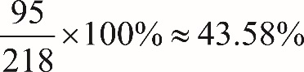 the fraction 95 over 218 times 100 percent which is approximately equal to 43.58, or about 44%. Therefore, the difference, to the nearest whole percent, between the percentage of students enrolled in Propel who had a G P A of 3.0 or greater and the percentage of students not enrolled in Propel who had a G P A of 3.0 or greater is 56 percent minus 44 percent equals 12 percent.
Incorrect answer
Choice A is incorrect. This answer choice is the result of finding the difference between the percentage of students in the study who both are enrolled in Propel and had a G P A of 3.0 or greater 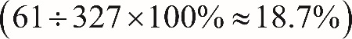 (61 divided by 327 times 100 percent is approximately equal to 18.7 percent) and the percentage of students in the study who both are enrolled in Propel and had a G P A less than 3.0 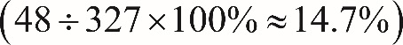 (48 divided by 327 times 100 percent is approximately equal to 14.7 percent). Choice B is incorrect. This answer choice is the result of finding the difference between the percentage of students in the study who both are not enrolled in Propel and had a G P A of 3.0 or greater. Choice C is incorrect. This answer choice may be the result of subtracting the number of students enrolled in Propel who had a G P A of 3.0 or greater from the number of students not enrolled in Propel who had a G P A of 3.0 or greater 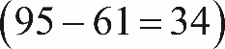 (95 minus 61 equals 34), then dividing the result by the total number of students in the study.

Explanation for question 18.
Correct answer
Choice B is correct. There are a total of 109 students enrolled in Propel (61 with a G P A of 3.0 or greater and 48 with a G P A of less than 3.0). If the ratio of boys to girls in Propel is 2 to 3, for every group of 5 students enrolled in Propel, 3 are girls. Since three-fifths of 109 is about 65.4, the best estimate of the number of girls enrolled in Propel is 65.
Incorrect answer
Choice A is incorrect; it is the best estimate for the number of boys enrolled in Propel. Choice C is incorrect; it is the result of multiplying the total number of students in Propel, 109, by two-thirds rather than first using the ratio of the number of boys to the number of girls to find the percentage of students in Propel who are girls. Choice D is incorrect. There are only 109 students enrolled in Propel, so there cannot be 131 girls enrolled in Propel.

Explanation for question 19.
Correct answer
Choice C is correct. Let S be the length, in inches, of each of the 4 sides of the square sculpture, and let T be the length, in inches, of each of the 3 sides of the equilateral triangle sculpture. Since the rod used to make the square sculpture is the same length as the rod used to make the triangle sculpture, 4 S equals 3 times T. The fact that each side of the triangle, T, is 2 inches longer than each side of the square, S, can be expressed by the equation T equals S plus 2. Substituting S plus 2 for T in the equation 4 S equals 3 times T gives 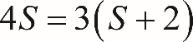 4 S equals 3 times, open parenthesis, S plus 2, close parenthesis. This equation simplifies to 4 S equals 3 S plus 6, so S equals 6 and T equals 8. Therefore, the length, in inches, of each rod is 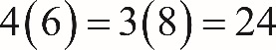 4 times 6, equals, 3 times 8, equals 24.
Incorrect answer
Choice A is incorrect. If the length of each rod were 16 inches, the length of each side of the square would be 16 divided by 4 equals 4 inches, and the length of each side of the triangle would be 16 divided by 3 is approximately equal to 5.3 inches. In this case, each side of the triangle is about 1.3 inches longer than each side of the square, but the question states that each side of the triangle is 2 inches longer than each side of the square. Choice B is incorrect. It is the result of correctly solving the system of equations to find that S equals 6 but incorrectly assuming that the length, in inches, of the rod is equal to 3 S, not 4 S. Choice D is incorrect. If the length of each rod were 30 inches, the length of each side of the square would be 30 divided by 4 equals 7.5 inches, and the length of each side of the triangle would be 30 divided by 3 equals 10 inches. In this case, each side of the triangle is 2.5 inches longer than each side of the square, but the question states that each side of the triangle is 2 inches longer than each side of the square.

Explanation for question 20.
Correct answer
Choice B is correct. The domain of the rational function 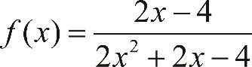 f of x equals, the fraction with numerator 2 x minus 4, and denominator 2 x squared, plus 2 x, minus 4, end fraction will be all real values of x except the values of x for which the denominator, 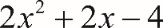 2 x squared, plus 2 x, minus 4, becomes 0. Solving the equation 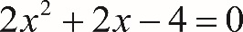 2 x squared, plus 2 x, minus 4, equals 0 gives x equals 1 and x equals negative 2. The equation in choice B, 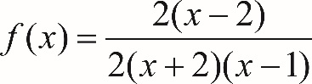 f of x equals, the fraction with numerator 2 times, open parenthesis, x minus 2, close parenthesis, and denominator 2 times, open parenthesis, x plus 2, close parenthesis, times, open parenthesis, x minus 1, close parenthesis, end fraction, is equivalent to the given function, since the numerator and denominator are just the factored forms of 2 x minus 4 and 2 x squared, plus 2 x, minus 4, respectively. Therefore, the equation in choice B is an equivalent form of 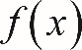 f of x that displays values not included in the domain as constants.
Incorrect answer
Choice A is incorrect because the values of x where the denominator is equal to 0 are not displayed as constants or coefficients. Choices C and D are incorrect because neither is equivalent to f of x equals, the fraction with numerator 2 x minus 4, and denominator 2 x squared, plus 2 x, minus 4, end fraction.

Explanation for question 21.
Correct answer
Choice B is correct. It is given that the equation 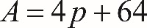 A equals 4 p plus 64 will relate the area A, in square feet, of the path and the perimeter p, in feet, of the fountain. This equation can be rewritten to express p in terms of A: subtracting 64 from each side of A equals 4 p plus 64 gives 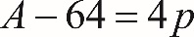 A minus 64 equals 4 p, and dividing by 4 and simplifying gives 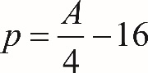 p equals, the fraction A over 4, end fraction, minus 16. For each additional square foot of area, the value of A increases by 1. Using 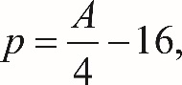 p equals, the fraction A over 4, end fraction, minus 16, an increase in A by 1 results in an increase in p by one-fourth. Therefore, the perimeter of the fountain increases by one-fourth foot for each additional square foot of the path’s area.
Incorrect answer
Choices A and D are incorrect and may be the result of misinterpreting the constant term 64 in the given equation. Choice C is incorrect; it is the number of square feet the area, A, of the path will increase for every increase in p by 1 foot rather than the number of feet the perimeter will increase for each additional square foot of area.

Explanation for question 22.
Correct answer
Choice D is correct. Since q is a function and its graph is a parabola, it follows that q is a quadratic function and the parabola is symmetric about the vertical line through its vertex. Thus, the x-coordinate of the vertex 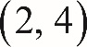 with coordinates 2 comma 4 is the average of the x-coordinates of the two x-intercepts 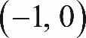 with coordinates negative 1 comma 0 and 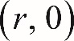 r comma 0. That is, 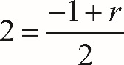 2 equals the fraction negative one plus r over 2. It follows that 4 equals negative 1 plus r, so r equals 5.
Incorrect answer
Choices A, B, and C are incorrect and may result from confusing the roles of the x-coordinates and y-coordinates in the question.

Explanation for question 23.
Correct answer
Choice D is correct. The temperature when chilling began was 100 degrees Celsius. Since the time the chilling began corresponds to the value t equals 0, the correct equation must yield the value C equals 100 for t equals 0. This eliminates choices A, B, and C. The temperature decreases at a constant rate from 100 degrees Celsius to 25 degrees Celsius. So the function that represents C in terms of t must be a linear function of the form C equals 100 minus a t, where a is the rate at which the temperature decreases, in degrees Celsius per second. The temperature decreases from 100 degrees Celsius to 25 degrees Celsius, or 75 degrees Celsius, in 5 seconds. This is a rate of decrease of 15 degrees Celsius per second. Thus, a equals 15. Therefore, the linear function in choice D represents correctly the temperature C, in degrees Celsius, as a function of the time t, in seconds, after the chilling began.
Incorrect answer
Choices A, B, and C are incorrect because each of these functions fails to give the correct value C equals 100 for t equals 0.

Explanation for question 24.
Correct answer
Choice C is correct. Let r sub E be the radius of Earth, and let r sub J be the radius of Jupiter. Since the radius of Jupiter is 11 times the radius of Earth, 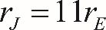 r sub J equals 11 r sub E. Assuming Jupiter is a sphere, the volume of Jupiter is 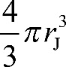 four-thirds pi, r sub J cubed. Substituting 11 r sub E for r sub J in this expression gives 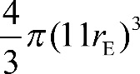 four-thirds pi, open parenthesis, 11 r sub E, close parenthesis, cubed, which can be rewritten as follows: 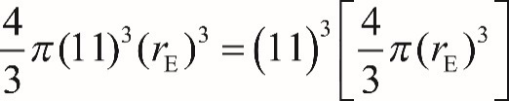 four-thirds pi, times 11 cubed, times r sub E cubed equals, 11 cubed times, open bracket, four-thirds pi, times r sub E cubed, close bracket. Since the expression in brackets is the volume of Earth, it follows that the volume of Jupiter is 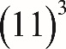 11 cubed, or 1,331, times larger than the volume of Earth.
Incorrect answer
Choice A is incorrect. This is the result of assuming that because the radius of Jupiter is 11 times the radius of Earth, the volume of Jupiter is 11 times the volume of Earth. If the radius of a sphere is multiplied by a factor of 11, its volume is multiplied by 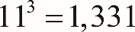 11 cubed equals 1,331, not 11. Choice B is incorrect. This is the result of multiplying the volume of the sphere by 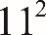 11 squared rather than 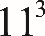 11 cubed. If the radius of a sphere is multiplied by a factor of 11, its volume is multiplied by 11 cubed equals 1,331, not 11 squared equals 121. Choice D is incorrect. If the radius of a sphere is multiplied by a factor of 11, the volume is multiplied by a factor of 11 cubed equals 1,331, not 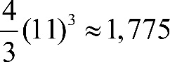 four-thirds times 11 cubed is approximately equal to 1,775.

Explanation for question 25.
Correct answer
Choice B is correct. Since the population of squirrels in the park has been doubling every 15 years, it means that if the current population of squirrels is A, 15 years later it will be 2 A. The increase of a function value at a rate that is proportional to the current function’s value is characteristic of an exponential growth function. For this example, the squirrel population can be modeled by the function 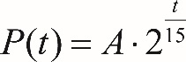 P of t equals A, times, 2 raised to the power, the fraction t over 15, where A is the population of squirrels at an initial moment in time, t is the number of years since the initial time, and 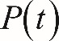 P of t is the population of the squirrels t years after the initial time.
Incorrect answer
Choices A and C are incorrect because the squirrel population is increasing by the same percentage each 15-year time period, not by the same amount. Choice D is incorrect because a population that is increasing by the same percentage over each time period is experiencing exponential growth, not linear growth.

Explanation for question 26.
Correct answer
Choice D is correct. The definition of a function describes the rule by which each input, x, is assigned a single output, f of x. So 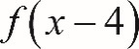 f of, open parenthesis, x minus 4, close parenthesis is the output obtained when the same rule, f, is applied to a different input, x minus 4. Therefore, to find f of, open parenthesis, x minus 4, close parenthesis, take the definition 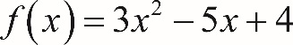 f of x equals, 3 x squared, minus 5 x, plus 4 and substitute x minus 4 for x throughout the equation to obtain f of, open parenthesis, x minus 4, close parenthesis, equals 3 times, open parenthesis, x minus four, close parenthesis, squared, minus 5 times, open parenthesis, x minus 4, close parenthesis, plus 4.

Now expand the right-hand side and collect like terms:
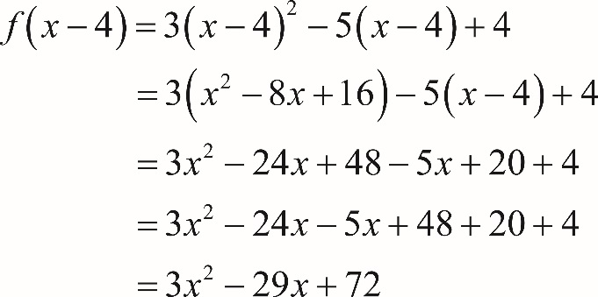
Equation 1: f of, open parenthesis, x minus 4, close parenthesis, equals 3 times, open parenthesis, x minus four, close parenthesis, squared, minus 5 times, open parenthesis, x minus 4, close parenthesis, plus 4.
Equation 2: f of, open parenthesis, x minus 4, close parenthesis, equals, 3 times, open parenthesis, x squared minus 8 x plus 16, close parenthesis, minus 5 times, open parenthesis, x minus 4, close parenthesis, plus 4.
Equation 3: f of, open parenthesis, x minus 4, close parenthesis, equals, 3 x squared, minus 24 x, plus 48, minus 5 x, plus 20, plus 4.
Equation 4: f of, open parenthesis, x minus 4, close parenthesis, equals, 3 x squared, minus 24 x, minus 5 x, plus 48, plus 20, plus 4.
Equation 5: f of, open parenthesis, x minus 4, close parenthesis, equals, 3 x squared, minus 29 x, plus 72.
Incorrect answer
Choice A is incorrect; it subtracts 4 from the right-hand side only, when to find f of, open parenthesis, x minus 4, close parenthesis in terms of x, x minus 4 should be substituted for x throughout the equation f of x equals, 3 x squared, minus 5 x, plus 4. Choices B and C are incorrect and likely result from errors in expanding and simplifying the equation f of, open parenthesis, x minus 4, close parenthesis equals, 3 times, open parenthesis, x minus 4, close parenthesis, squared, minus 5 times, open parenthesis, x minus 4, close parenthesis, plus 4.

Explanation for question 27.
Correct answer
Choice D is correct. If 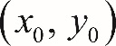 the point with coordinates x sub 0 comma y sub 0 is the point at which the two lines intersect, the coordinates x sub 0 and y sub 0 must satisfy each of the given equations in the following system of equations:
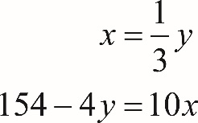
x equals one-third y
And
154 minus 4 y equals 10 x
This system can be solved by writing the second equation in terms of only x. To do so, first multiply each side of the first equation, 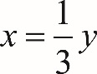 x equals one-third y, by 3, which gives 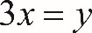 3 x equals y. Substituting 3 x for y in the second equation, 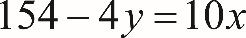 154 minus 4 y equals 10 x, gives 154 minus 12 x equals 10 x. Adding 12 x to each side of 154 minus 12 x equals 10 x gives 154 equals 22 x, so x equals 7. Finally, substituting 7 for x in the equation x equals one-third y gives 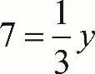 7 equals one-third y, and multiplying each side of 7 equals one-third y by 3 gives 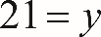 21 equals y. When the two equations are graphed in the x y-plane, the resulting lines intersect at the point 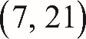 with coordinates 7 comma 21.
Incorrect answer
Choices A, B, and C are incorrect. Each of these points lies on the line with equation x equals one-third y, but none of these points lies on the line with equation 154 minus 4 y equals 10 x. For example, the point 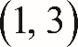 with coordinates 1 comma 3 does not lie on the line with equation 154 minus 4 y equals 10 x because substituting x equals 1 and 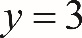 y equals 3 in the equation gives 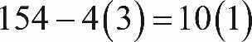 154 minus 4 times 3 equals 10 times 1; this simplifies to 142 equals 10, which is not a true statement.

Explanation for question 28.
Correct answer
The correct answer is 65. Based on the table, 10 Szechuan chicken meals contain 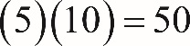 5 times 10 equals 50 grams of fat and 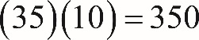 35 times 10 equals 350 grams of carbohydrates. So the greatest number of stir-fry meals that John can purchase must contain no more than 350 minus 50 equals 300 grams of fat and no more than 2975 minus 350 equals 2625 grams of carbohydrates. It follows that the greatest number of stir-fry meals he can purchase so that the combination will satisfy the fat requirement is 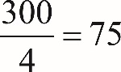 the fraction 300 over 4 equals 75, and the greatest number of stir-fry meals he can purchase so that the combination will satisfy the carbohydrate requirement is 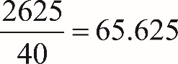 the fraction 2625 over 40 equals 65.625. Since John cannot purchase parts of a meal and purchasing 66 stir-fry meals would exceed the carbohydrate requirement, the greatest number of meals he can purchase so that the carbohydrate requirement will be satisfied is 65. Therefore, the greatest number of stir-fry meals he can purchase so that the combination will satisfy both requirements is 65.

Explanation for question 29.
Correct answer
The correct answer is 0 or 12. To solve the given system of equations, one can use the second equation, 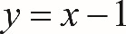 y equals x minus 1, and substitute x minus 1 for y in the first equation, giving 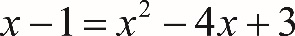 x minus 1 equals x squared minus 4 x plus 3. This equation can be rewritten as 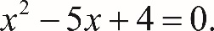 x squared minus 5 x plus 4 equals 0. Since 1 and 4 are the two numbers whose sum is 5 and whose product is 4, they are the solutions to the equation 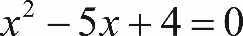 x squared minus 5 x plus 4 equals 0. From the equation y equals x minus 1, it follows that 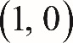 the ordered pairs 1 comma 0 and 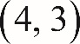 4 comma 3 are the solutions to the given system of equations. Therefore, the value of the product x y can be 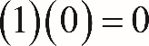 1 times 0 equals 0 or 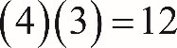 4 times 3 equals 12. Either 0 or 12 can be gridded as the correct answer.

Explanation for question 30.
Correct answer
The correct answer is 1368. According to the graph, the king crab supply in 2006 was 180 million pounds. It is given that 60% of this supply was sold at $8 per pound and the rest of the supply was sold at $7 per pound. It follows that 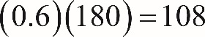 0.6 times 180 equals 108 million pounds of king crab was sold at $8 per pound, and 180 minus 108 equals 72 million pounds of king crab was sold at $7 per pound. Therefore, the revenue generated, in millions of dollars, from the sales of king crab in 2006 was 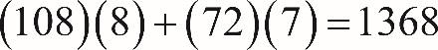 108 times 8 plus 72 times 7 equals 1368.

Explanation for question 31.
Correct answer
The correct answer is 85. According to the graph, the king crab supply in 2011 was 80 million pounds. So at the price of $17 per pound, the revenue generated, in millions of dollars, from the sales of king crab in 2011 was 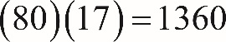 80 times 17 equals 1360. Since x millions pounds of king crab was sold in 2012 at the price of $16 per pound, the revenue in 2012 was 16 x million dollars. It is given that the revenue generated from the sales of king crab in 2011 was the same as the revenue in 2012. Therefore, 16 x equals 1360, so x equals 85.

