The S A T®
Assistive Technology Compatible Test Form

Practice Test 10

Answers and explanations for section 3, Math Test—No Calculator

Explanation for question 1.
Correct answer
Choice B is correct. Subtracting z from both sides of 2 z plus 1, equals z results in z plus 1, equals 0. Subtracting 1 from both sides of z plus 1, equals 0 results in z equals negative 1.
Incorrect answer
Choices A, C, and D are incorrect. When each of these values is substituted for z in the given equation, the result is a false statement. Substituting negative 2 for z yields 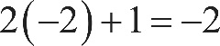 2 times negative 2, plus 1, equals negative 2, or negative 3 equals, negative 2. Substituting one half for z yields 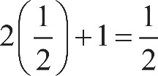 2 times one half, plus 1, equals one half, or 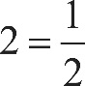 2 equals one half. Lastly, substituting 1 for z yields 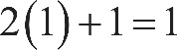 2 times 1, plus 1, equals 1, or 3 equals 1.

Explanation for question 2.
Correct answer
Choice C is correct. To complete the purchase, the initial payment of $60 plus the w weekly payments of $30 must be equivalent to the $300 price of the television. The total, in dollars, of w weekly payments of $30 can be expressed by 30 w. It follows that 300 equals, 30 w plus 60 can be used to find the number of weekly payments, w, required to complete the purchase.
Incorrect answer
Choice A is incorrect. Since the television is to be purchased with an initial payment and w weekly payments, the price of the television must be equivalent to the sum, not the difference, of these payments. Choice B is incorrect. This equation represents a situation where the television is purchased using only w weekly payments of $30, with no initial payment of $60. Choice D is incorrect. This equation represents a situation where the w weekly payments are $60 each, not $30 each, and the initial payment is $30, not $60. Also, since the television is to be purchased with weekly payments and an initial payment, the price of the television must be equivalent to the sum, not the difference, of these payments.

Explanation for question 3.
Correct answer
Choice B is correct. Since the relationship between the merchandise weight x and the shipping charge 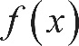 f of x is linear, a function in the form 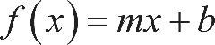 f of x equals, m x plus b, where m and b are constants, can be used. In this situation, the constant m represents the additional shipping charge, in dollars, for each additional pound of merchandise shipped, and the constant b represents a one-time charge, in dollars, for shipping any weight, in pounds, of merchandise. Using any two pairs of values from the table, such as 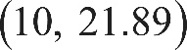 10 comma 21.89 and 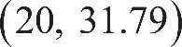 20 comma 31.79, and dividing the difference in the charges by the difference in the weights gives the value of m: 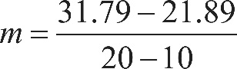 m equals, the fraction with numerator 31.79, minus 21.89, and denominator 20 minus 10, end fraction, which simplifies to 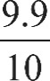 9.9 over 10, or 0.99. Substituting the value of m and any pair of values from the table, such as 10 comma 21.89, for x and f of x, respectively, gives the value of b: 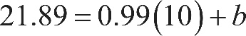 21.89 equals, 0.99 times 10, plus b, or b equals, 11.99. Therefore, the function 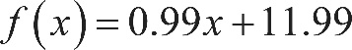 f of x equals, 0.99 x, plus 11.99 can be used to determine the total shipping charge f of x, in dollars, for an order with a merchandise weight of x pounds.
Incorrect answer
Choices A, C, and D are incorrect. If any pair of values from the table is substituted for x and f of x, respectively, in these functions, the result is false. For example, substituting 10 for x and 21.89 for f of x in 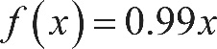 f of x equals, 0.99 x yields 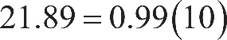 21.89 equals, 0.99 times 10, or 21.89, equals 9.9, which is false. Similarly, substituting the values 10 comma 21.89 for x and f of x into the functions in choices C and D results in 21.89, equals 33.9 and 21.89, equals 50.84, respectively. Both are false.

Explanation for question 4.
Correct answer
Choice C is correct. It’s given that 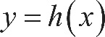 y equals, h of x, thus the y-coordinate of each point on the graph corresponds to the height, in feet, of each column. A Doric column with a base diameter of 5 feet is represented by the point 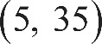 with coordinates 5 comma 35, and a Doric column with a base diameter of 2 feet is represented by the point 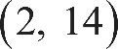 with coordinates 2 comma 14. Therefore, the column with a base diameter of 5 feet has a height of 35 feet, and the column with a base diameter of 2 feet has a height of 14 feet. It follows that the difference in heights of these two columns is 35 minus 14, or 21 feet.
Incorrect answer
Choice A is incorrect. This value is the slope of the line and represents the increase in the height of a Doric column for each increase in the base diameter by 1 foot. Choice B is incorrect. This value represents the height of a Doric column with a base diameter of 2 feet, or the difference in height between a Doric column with base diameter of 5 feet and a Doric column with base diameter of 3 feet. Choice D is incorrect and may result from conceptual or calculation errors.

Explanation for question 5.
Correct answer
Choice A is correct. The expression 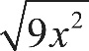 the square root of 9 x squared, end root can be rewritten as 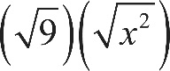 the square root of 9, end root, times, the square root of x squared, end root. The square root symbol in an expression represents the principal square root, or the positive square root, thus 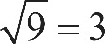 the square root of 9, equals 3. Since x is greater than 0, taking the square root of the second factor, 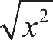 the square root of x squared, end root, gives x. It follows that the square root of 9 x squared, end root is equivalent to 3 x.
Incorrect answer
Choice B is incorrect and may result from rewriting the square root of 9 x squared, end root as 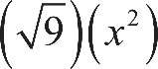 the square root of 9, end root, times x squared rather than the square root of 9, end root, times, the square root of x squared, end root. Choices C and D are incorrect and may result from misunderstanding the operation indicated by a radical symbol. In both of these choices, instead of finding the square root of the coefficient 9, the coefficient has been multiplied by 2. Additionally, in choice D, 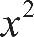 x squared has been squared to give 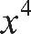 x to the fourth power, instead of taking the square root of x squared to get x.

Explanation for question 6.
Correct answer
Choice A is correct. Factoring the numerator of the rational expression 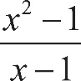 the fraction with numerator x squared, minus 1, and denominator x minus 1, end fraction yields 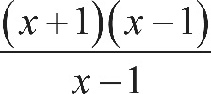 the fraction with numerator open parenthesis, x plus 1, close parenthesis, times, open parenthesis, x minus 1, close parenthesis, and denominator x minus 1, end fraction. The expression the fraction with numerator open parenthesis, x plus 1, close parenthesis, times, open parenthesis, x minus 1, close parenthesis, and denominator x minus 1, end fraction be rewritten as 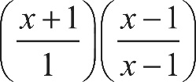 open parenthesis, the fraction with numerator x plus 1, and denominator 1, close parenthesis, times, open parenthesis, the fraction with numerator x minus 1, and denominator x minus 1, end fraction, close parenthesis. Since 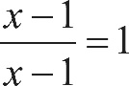 the fraction with numerator x minus 1, and denominator x minus 1, end fraction, equals 1, when x is not equal to 1, it follows that 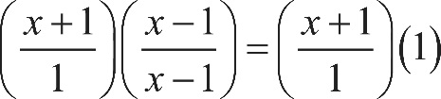 open parenthesis, the fraction with numerator x plus 1, and denominator 1, close parenthesis, times, open parenthesis, the fraction with numerator x minus 1, and denominator x minus 1, end fraction, close parenthesis, equals, open parenthesis, the fraction with numerator x plus 1, and denominator 1, close parenthesis, times 1 or x plus 1. Therefore, the given equation is equivalent to x plus 1, equals negative 2. Subtracting 1 from both sides of x plus 1, equals negative 2 yields x equals negative 3.
Incorrect answer
Choices B, C, and D are incorrect. Substituting 0, 1, or negative 1, respectively, for x in the given equation yields a false statement. Substituting 0 for x in the given equation yields 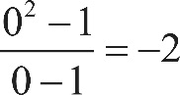 the fraction with numerator 0 squared, minus 1, and denominator 0 minus 1, end fraction, equals negative 2 or 1 equals negative 2, which is false. Substituting 1 for x in the given equation makes the left-hand side 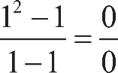 the fraction with numerator 1 squared, minus 1, and denominator 1 minus 1, end fraction, equals, the fraction 0 over 0, which is undefined and not equal to negative 2. Substituting negative 1 for x in the given equation yields 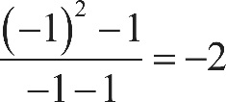 the fraction with numerator, open parenthesis, negative 1, close parenthesis, squared, minus 1, and denominator negative 1, minus 1, end fraction, equals negative 2, or 0 equals negative 2, which is false. Therefore, these values don’t satisfy the given equation.

Explanation for question 7.
Correct answer
Choice D is correct. Since 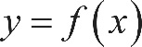 y equals, f of x, the value of 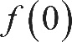 f of 0 is equal to the value of f of x, or y, when x equals 0. The graph indicates that when x equals 0, 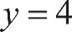 y equals 4. It follows that the value of 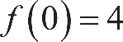 f of 0 equals 4.
Incorrect answer
Choice A is incorrect. If the value of f of 0 were 0, then when x equals 0, the value of f of x or y, would be 0 and the graph would pass through the point 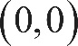 with coordinates 0 comma 0. Choice B is incorrect. If the value of f of 0 were 2, then when x equals 0, the value of f of x, or y, would be 2 and the graph would pass through the point 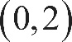 with coordinates 0 comma 2. Choice C is incorrect. If the value of f of 0 were 3, then when x equals 0, the value of f of x, or y, would be 3 and the graph would pass through the point 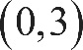 with coordinates 0 comma 3.

Explanation for question 8.
Correct answer
Choice C is correct. Since point B lies on side A D, angles A B C and C B D are supplementary. It’s given that angle A B C is a right angle; therefore, its measure is 90 degrees. It follows that the measure of angle C B D is 180 degrees minus 90 degrees, or 90 degrees. By the angle addition postulate, the measure of angle C B D is equivalent to x degrees, plus 2 x degrees, plus 2 x degrees. Therefore, 90 equals, x plus 2 x, plus 2 x. Combining like terms gives 90 equals 5 x. Dividing both sides of this equation by 5 yields x equals 18. Therefore, the value of 3 x is 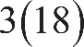 3 times 18, or 54.
Incorrect answer
Choice A is incorrect. This is the value of x. Choice B is incorrect. This is the value of 2 x. Choice D is incorrect. This is the value of 4 x.

Explanation for question 9.
Correct answer
Choice C is correct. The equation defining any line can be written in the form 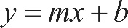 y equals, m x plus b, where m is the slope of the line and b is the y-coordinate of the y-intercept. Line l passes through the point 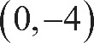 with coordinates 0 comma negative 4, which is the y-intercept. Therefore, for line l, b equals negative 4. The slope of a line is the ratio of the difference between the y-coordinates of any two points to the difference between the x-coordinates of the same points. Calculating the slope using two points that line l passes through, 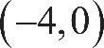 the point with coordinates negative 4 comma 0 and the point with coordinates 0 comma negative 4, gives 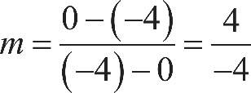 m equals, the fraction with numerator 0 minus negative 4, and denominator negative 4 minus 0, end fraction, equals, the fraction 4 over negative 4, or negative 1. Since m equals negative 1 and b equals negative 4, the equation of line l can be written as 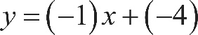 y equals, negative 1 times x, plus negative 4, or 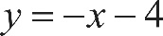 y equals, negative x minus 4. Adding x to both sides of y equals, negative x minus 4 yields 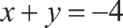 x plus y, equals negative 4.
Incorrect answer
Choices A and B are incorrect. These equations both represent lines with a positive slope, but line l has a negative slope. Choice D is incorrect. This equation represents a line that passes through the points 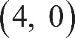 with coordinates 4 comma 0 and 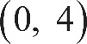 0 comma 4, not the points 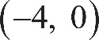 with coordinates negative 4 comma 0 and 0 comma negative 4.

Explanation for question 10.
Correct answer
Choice D is correct. Since the graph represents the equation 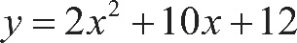 y equals, 2 x squared, plus 10 x, plus 12, it follows that each point 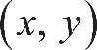 with coordinates x comma y on the graph is a solution to this equation. Since the graph crosses the y-axis at 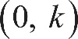 the point with coordinates 0 comma k, then substituting 0 for x and k for y in y equals, 2 x squared, plus 10 x, plus 12 creates a true statement: 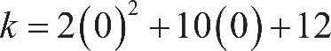 k equals, 2 times 0 squared, plus, 10 times 0, plus 12, or k equals 12.
Incorrect answer
Choice A is incorrect. If k equals 2 when x equals 0, it follows that 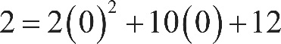 2 equals, 2 times 0 squared, plus, 10 times 0, plus 12, or 2 equals 12, which is false. Choice B is incorrect. If k equals 6 when x equals 0, it follows that 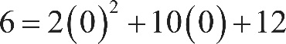 6 equals, 2 times 0 squared, plus, 10 times 0, plus 12, or 6 equals 12, which is false. Choice C is incorrect. If k equals 10 when x equals 0, it follows that 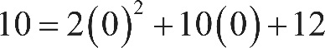 10 equals, 2 times 0 squared, plus, 10 times 0, plus 12, or 10 equals 12 which is false.

Explanation for question 11.
Correct answer
Choice A is correct. A circle in the x y-plane with center 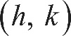 h comma k and radius r is defined by the equation 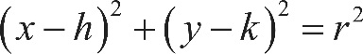 open parenthesis, x minus h, close parenthesis, squared, plus, open parenthesis, y minus k, close parenthesis, squared, equals r squared. Therefore, an equation of a circle with center 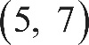 5 comma 7 and radius 2 is 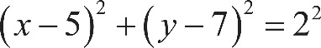 open parenthesis, x minus 5, close parenthesis, squared, plus, open parenthesis, y minus 7, close parenthesis, squared, equals 2 squared, or 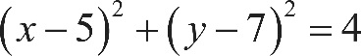 open parenthesis, x minus 5, close parenthesis, squared, plus, open parenthesis, y minus 7, close parenthesis, squared, equals 4.
Incorrect answer
Choice B is incorrect. This equation defines a circle with center 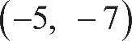 negative 5 comma negative 7 and radius 2. Choice C is incorrect. This equation defines a circle with center 5 comma 7 and radius 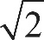 the square root of 2. Choice D is incorrect. This equation defines a circle with center negative 5 comma negative 7 and radius the square root of 2.

Explanation for question 12.
Correct answer
Choice B is correct. Since figures are drawn to scale unless otherwise stated and triangle A B C is similar to triangle D E F, it follows that the measure of angle B is equal to the measure of angle E. Furthermore, it follows that side A B corresponds to side D E and that side B C corresponds to side E F. For similar triangles, corresponding sides are proportional, so 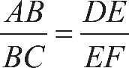 the length of side A B, over the length of side B C, equals, the length of side D E, over the length of side E F. In right triangle D E F, the cosine of angle E, or cosine of E, is equal to the length of the side adjacent to angle E divided by the length of the hypotenuse in triangle D E F. Therefore, 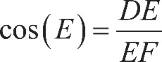 cosine of E equals, the length of side D E, over the length of side E F, which is equivalent to 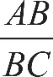 the length of side A B, over the length of side B C. Therefore, 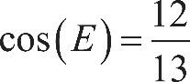 cosine of E equals, 12 over 13.
Incorrect answer
Choice A is incorrect. This value represents the tangent of angle F, or 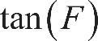 tangent of F, which is defined as the length of the side opposite angle F divided by the length of the side adjacent to angle F. Choice C is incorrect. This value represents the tangent of angle E, or tangent of E, which is defined as the length of the side opposite angle E divided by the length of the side adjacent to angle E. Choice D is incorrect. This value represents the sine of angle E, or sine of E, which is defined as the length of the side opposite angle E divided by the length of the hypotenuse.

Explanation for question 13.
Correct answer
Choice C is correct. The x-intercepts of the graph of 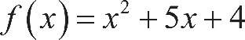 f of x equals, x squared, plus 5 x, plus 4 are the points 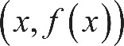 with coordinates x comma f of x on the graph where 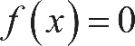 f of x equals 0. Substituting 0 for f of x in the function equation yields 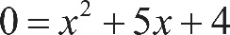 0 equals, x squared, plus 5 x, plus 4. Factoring the right-hand side of 0 equals, x squared, plus 5 x, plus 4 yields 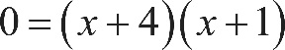 0 equals, open parenthesis, x plus 4, close parenthesis, times, open parenthesis, x plus 1, close parenthesis. If 0 equals, open parenthesis, x plus 4, close parenthesis, times, open parenthesis, x plus 1, close parenthesis, then 0 equals, x plus 4 or 0 equals, x plus 1. Solving both of these equations for x yields x equals negative 4 and x equals negative 1. Therefore, the x-intercepts of the graph of f of x equals, x squared, plus 5 x, plus 4 are the point with coordinates negative 4 comma 0 and 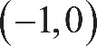 the point with coordinates negative 1 comma 0. Since both points lie on the x-axis, the distance between the point with coordinates negative 4 comma 0 and the point with coordinates negative 1 comma 0 is equivalent to the number of unit spaces between negative 4 and negative 1 on the x-axis, which is 3.
Incorrect answer
Choice A is incorrect. This is the distance from the origin to the x-intercept with coordinates negative 1 comma 0. Choice B is incorrect and may result from incorrectly calculating the x-intercepts. Choice D is incorrect. This is the distance from the origin to the x-intercept with coordinates negative 4 comma 0.

Explanation for question 14.
Correct answer
Choice B is correct. Squaring both sides of the equation 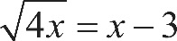 the square root of 4 x, end root, equals, x minus 3 yields 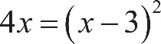 4 x equals, open parenthesis, x minus 3, close parenthesis, squared, or 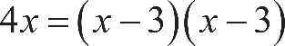 4 x equals, open parenthesis, x minus 3, close parenthesis, times, open parenthesis, x minus 3, close parenthesis. Applying the distributive property on the right-hand side of the equation 4 x equals, open parenthesis, x minus 3, close parenthesis, times, open parenthesis, x minus 3, close parenthesis yields 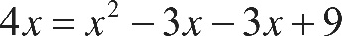 4 x equals, x squared, minus 3 x, minus 3 x, plus 9. Subtracting 4 x from both sides of 4 x equals, x squared, minus 3 x, minus 3 x, plus 9 yields 0 equals, x squared, minus 3 x, minus 3 x, minus 4 x, plus 9, which can be rewritten as 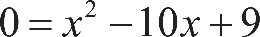 0 equals, x squared, minus 10 x, plus 9. Factoring the right-hand side of 0 equals, x squared, minus 10 x, plus 9 gives 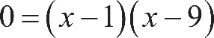 0 equals, open parenthesis, x minus 1, close parenthesis, times, open parenthesis, x minus 9, close parenthesis. By the zero product property, if 0 equals, open parenthesis, x minus 1, close parenthesis, times, open parenthesis, x minus 9, close parenthesis, then 0 equals, x minus 1 or 0 equals, x minus 9. Adding 1 to both sides of 0 equals, x minus 1 gives x equals 1. Adding 9 to both sides of 0 equals, x minus 9 gives x equals 9. Substituting these values for x into the given equation will determine whether they satisfy the equation. Substituting 1 for x in the given equation yields 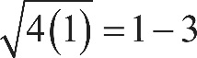 the square root of 4 times 1, end root, equals, 1 minus 3, or 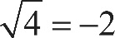 the square root of 4, equals negative 2, which is false. Therefore, x equals 1 doesn’t satisfy the given equation. Substituting 9 for x in the given equation yields 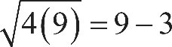 the square root of 4 times 9, end root, equals, 9 minus 3 or 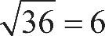 the square root of 36, equals 6, which is true. Therefore, x equals 9 satisfies the given equation.
Incorrect answer
Choices A and C are incorrect because x equals 1 doesn’t satisfy the given equation: 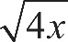 the square root of 4 x, end root represents the principal square root of 4 x, which can’t be negative. Choice D is incorrect because x equals 9 does satisfy the given equation.

Explanation for question 15.
Correct answer
Choice A is correct. A system of two linear equations has no solution if the graphs of the lines represented by the equations are parallel and are not equivalent. Parallel lines have equal slopes but different y-intercepts. The slopes and y-intercepts for the two given equations can be found by solving each equation for y in terms of x, thus putting the equations in slope-intercept form. This yields 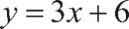 y equals, 3 x plus 6 and 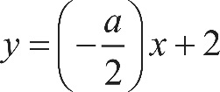 y equals, open parenthesis, the negative of the fraction a, over 2, close parenthesis, times x, plus 2. The slope and y-intercept of the line with equation 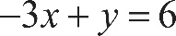 negative 3 x, plus y, equals 6 are 3 and 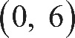 the point with coordinates 0 comma 6, respectively. The slope and y-intercept of the line with equation 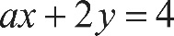 a, x plus 2 y, equals 4 are represented by the expression 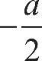 the negative of the fraction a, over 2 and the point 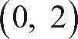 with coordinates 0 comma 2, respectively. The value of a can be found by setting the two slopes equal to each other, which gives 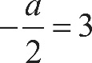 the negative of the fraction a, over 2, equals 3. Multiplying both sides of this equation by negative 2 gives a, equals negative 6. When a, equals negative 6, the lines are parallel and have different y-intercepts.
Incorrect answer
Choices B, C, and D are incorrect because these values of a would result in two lines that are not parallel, and therefore the resulting system of equations would have a solution.

Explanation for question 16.
Correct answer
The correct answer is 2200. If the total shipping cost was $47,000, then 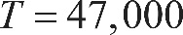 T equals 47,000. If 3000 units were shipped to the farther location, then 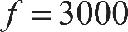 f equals 3000. Substituting 47,000 for T and 3000 for f in the equation 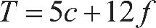 T equals, 5 c plus 12 f yields 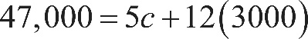 47,000 equals, 5 c plus, 12 times 3000. Multiplying 12 by 3000 yields 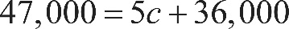 47,000 equals, 5 c plus 36,000. Subtracting 36,000 from both sides of the equation yields 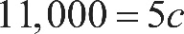 11,000 equals 5 c. Dividing both sides by 5 yields c equals 2200. Therefore, 2200 units were shipped to the closer location.

Explanation for question 17.
Correct answer
The correct answer is 5. By definition of absolute value, if 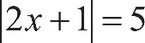 the absolute value of, 2 x plus 1, end absolute value, equals 5, then 2 x plus 1, equals 5 or 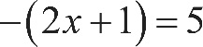 the negative of, open parenthesis, 2 x plus 1, close parenthesis, equals 5, which can be rewritten as 2 x plus 1, equals negative 5. Subtracting 1 from both sides of 2 x plus 1, equals 5 and 2 x plus 1, equals negative 5 yields 2 x equals 4 and 2 x equals negative 6, respectively. Dividing both sides of 2 x equals 4 and 2 x equals negative 6 by 2 yields x equals 2 and x equals negative 3, respectively. If a and b are the solutions to the given equation, then a, equals 2 and b equals negative 3. It follows then that 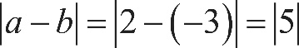 the absolute value of, a, minus b, end absolute value, equals, the absolute value of, 2 minus negative 3, end absolute value, which equals the absolute value of 5, which is 5. Similarly, if a, equals negative 3 and b equals 2, it follows that 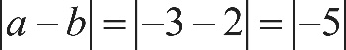 the absolute value of, a, minus b, end absolute value, equals, the absolute value of, negative 3 minus 2, end absolute value, equals the absolute value of negative 5, which is also 5.

Explanation for question 18.
Correct answer
The correct answer is 1.21. It’s given that each year the value of the antique is estimated to increase by 10% over its value the previous year. Increasing a quantity by 10% is equivalent to the quantity increasing to 110% of its original value or multiplying the original quantity by 1.1. Therefore, 1 year after the purchase, the estimated value of the antique is 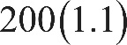 200 times 1.1 dollars. Then, 2 years after purchase, the estimated value of the antique is 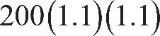 200 times, 1.1 times 1.1, or 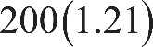 200 times 1.21 dollars. It’s given that the estimated value of the antique after 2 years is 200 a dollars. Therefore, 200 times 1.21, equals 200 a. It follows that a, equals 1.21.

Explanation for question 19.
Correct answer
The correct answer is 2500. Adding the given equations yields open parenthesis, 2 x plus 3 y, close parenthesis, plus, open parenthesis, 3 x plus 2 y, close parenthesis, equals, open parenthesis, 1200 plus 1300, close parenthesis. Combining like terms yields 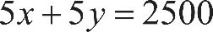 5 x plus 5 y, equals 2500. Therefore, the value of 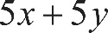 5 x plus 5 y is 2500.

Explanation for question 20.
Correct answer
The correct answer is 20. Factoring the expression u squared, minus t squared yields 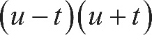 open parenthesis, u minus t, close parenthesis, times, open parenthesis, u plus t, close parenthesis. Therefore, the expression 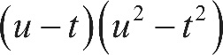 open parenthesis, u minus t, close parenthesis, times, open parenthesis, u squared, minus t squared, close parenthesis can be rewritten as 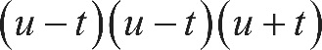 open parenthesis, u minus t, close parenthesis, times, open parenthesis, u minus t, close parenthesis, times, open parenthesis, u plus t, close parenthesis. Substituting 5 for u plus t and 2 for u minus t in this expression yields 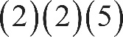 2 times 2, times 5, which is equal to 20.

