Reading Test
52 Questions

Turn to Section 1 of your answer sheet to answer the questions in this section.

Directions
Each passage or pair of passages in this section is followed by a number of questions. After reading each passage or pair, choose the best answer to each question based on what is stated or implied in the passage or passages and in any accompanying graphics (such as a table or graph).

Questions 1 through 10 are based on the following passage.
This passage is adapted from Mary Helen Stefaniak, The Cailiffs of Baghdad, Georgia: A Novel. ©2010 by Mary Helen Stefaniak.

Miss Grace Spivey arrived in Threestep, Georgia, in August 1938. She stepped off the train wearing a pair of thick-soled boots suitable for hiking, a navy blue dress, and a little white tam that rode the waves of her red hair at a gravity-defying angle. August was a hellish month to step off the train in Georgia, although it was nothing, she said, compared to the 119 degrees that greeted her when she arrived one time in Timbuktu, which, she assured us, was a real place in Africa. I believe her remark irritated some of the people gathered to welcome her on the burned grass alongside the tracks. When folks are sweating through their shorts, they don’t like to hear that this is nothing compared to someplace else. Irritated or not, the majority of those present were inclined to see the arrival of the new schoolteacher in a positive light. Hard times were still upon us in 1938, but, like my momma said, “We weren’t no poorer than we’d ever been,” and the citizens of Threestep were in the mood for a little excitement.

Miss Spivey looked like just the right person to give it to them. She was, by almost anyone’s standards, a woman of the world. She’d gone to boarding schools since she was six years old; she’d studied French in Paris and drama in London; and during what she called a “fruitful intermission” in her formal education, she had traveled extensively in the Near East and Africa with a friend of her grandmother’s, one Janet Miller, who was a medical doctor from Nashville, Tennessee. After her travels with Dr. Miller, Miss Spivey continued her education by attending Barnard College in New York City. She told us all that at school the first day. When my little brother Ralphord asked what did she study at Barnyard College, Miss Spivey explained that Barnard, which she wrote on the blackboard, was the sister school of Columbia University, of which, she expected, we all had heard.

It was there, she told us, in the midst of trying to find her true mission in life, that she wandered one afternoon into a lecture by the famous John Dewey, who was talking about his famous book, Democracy and Education. Professor Dewey was in his seventies by then, Miss Spivey said, but he still liked to chat with students after a lecture—especially female students, she added—sometimes over coffee, and see in their eyes the fire his words could kindle. It was after this lecture and subsequent coffee that Miss Spivey had marched to the Teacher’s College and signed up, all aflame. Two years later, she told a cheery blue-suited woman from the W P A 1 that she wanted to bring democracy and education to the poorest, darkest, most remote and forgotten corner of America.

They sent her to Threestep, Georgia.

Miss Spivey paused there for questions, avoiding my brother Ralphord’s eye.

What we really wanted to know about—all twenty-six of us across seven grade levels in the one room—was the pearly white button hanging on a string in front of the blackboard behind the teacher’s desk up front. That button on a string was something new. When Mavis Davis (the only bona fide seventh grader, at age thirteen) asked what it was for, Miss Spivey gave the string a tug, and to our astonishment, the whole world—or at least a wrinkled map of it—unfolded before our eyes. Her predecessor, Miss Chandler, had never once made use of that map, which was older than our fathers, and until that moment, not a one of us knew it was there.

Miss Spivey showed us on the map how she and Dr. Janet Miller had sailed across the Atlantic Ocean and past the Rock of Gibraltar into the Mediterranean Sea. Using the end of a ruler, she gently tapped such places as Morocco and Tunis and Algiers to mark their route along the top of Africa. They spent twenty hours on the train to Baghdad, she said, swathed in veils against the sand that crept in every crack and crevice.

“And can you guess what we saw from the train?” Miss Spivey asked. We could not. “Camels!” she said. “We saw a whole caravan of camels.” She looked around the room, waiting for us to be amazed and delighted at the thought.

We all hung there for a minute, thinking hard, until Mavis Davis spoke up.

“She means like the three kings rode to Bethlehem,” Mavis said, and she folded her hands smugly on her seventh-grade desk in the back of the room.

Miss Spivey made a mistake right then. Instead of beaming upon Mavis the kind of congratulatory smile that old Miss Chandler would have bestowed on her for having enlightened the rest of us, Miss Spivey simply said, “That’s right.”

1 The Works Progress Administration (W P A) was a government agency that hired people for public and cultural development projects and services.

Question 1.
The narrator of the passage can best be described as
A. one of Miss Spivey’s former students.
B. Miss Spivey’s predecessor.
C. an anonymous member of the community.
D. Miss Spivey herself.

Question 2.
In the passage, Threestep is mainly presented as a
A. summer retreat for vacationers.
B. small rural town.
C. town that is home to a prominent university.
D. comfortable suburb.

Question 3.
It can reasonably be inferred from the passage that some of the people at the train station regard Miss Spivey’s comment about the Georgia heat with
A. sympathy, because they assume that she is experiencing intense heat for the first time.
B. disappointment, because they doubt that she will stay in Threestep for very long.
C. embarrassment, because they imagine that she is superior to them.
D. resentment, because they feel that she is minimizing their discomfort.

Question 4.
Which choice provides the best evidence for the answer to question 3?
A. Sentence 2 of paragraph 1 (“She stepped . . . angle”)
B. Sentences 4 and 5 of paragraph 1 (“I believe . . . else”)
C. Sentences 6 and 7 of paragraph 1 (“Irritated . . . excitement”)
D. The first part of sentence 3 of paragraph 2 (“She’d gone . . . London”)

Question 5.
Miss Spivey most likely uses the phrase “fruitful intermission” (sentence 3 of paragraph 2) to indicate that
A. she benefited from taking time off from her studies in order to travel.
B. her travels with Janet Miller encouraged her to start medical school.
C. her early years at boarding school resulted in unanticipated rewards.
D. what she thought would be a short break from school lasted several years.

Question 6.
The interaction between Miss Spivey and Ralphord serves mainly to
A. suggest that Miss Spivey has an exaggerated view of what information should be considered common knowledge.
B. establish a friendly dynamic between the charming schoolchildren and their indulgent and doting new instructor.
C. introduce Ralphord as a precocious young student and Miss Spivey as a dismissive and disinterested teacher.
D. demonstrate that the children want to amuse Miss Spivey with their questions.

Question 7.
In paragraph 3, what is the narrator most likely suggesting by describing Miss Spivey as having “wandered” (sentence 1 of paragraph 3) in one situation and “marched” (sentence 3 of paragraph 3) in another situation?
A. Dewey, knowing Miss Spivey wasn’t very confident in her ability to teach, instilled in her a sense of determination.
B. Talking with Dewey over coffee made Miss Spivey realize how excited she was to teach in the poorest, most remote corner of America.
C. After two years spent studying, Miss Spivey was anxious to start teaching and be in charge of her own classroom.
D. Miss Spivey’s initial encounter with Dewey’s ideas was somewhat accidental but ultimately motivated her to decisive action.

Question 8.
According to the passage, Miss Spivey ended up in Threestep as a direct result of
A. her friendship with Janet Miller.
B. attending college in New York City.
C. talking with a woman at the W P A.
D. Miss Chandler’s retirement from teaching.

Question 9.
In the passage, when Miss Spivey announces that she had seen camels, the students’ reaction suggests that they are
A. delighted.
B. fascinated.
C. baffled.
D. worried.

Question 10.
Which choice provides the best evidence for the answer to question 9?
A. Sentence 5 of paragraph 8 (“She looked . . . thought”)
B. Sentence 1 of paragraph 9 (“We all . . . up”)
C. Sentence 1 of paragraph 10 (“She means . . . room”)
D. Sentence 2 of paragraph 11 (“Instead . . . right”)

Questions 11 through 21 are based on the following passage and supplementary material.
This passage is adapted from David Owen, The Conundrum: How Scientific Innovation, Increased Efficiency, and Good Intentions Can Make Our Energy and Climate Problems Worse. ©2011 by David Owen.

Building good transit isn’t a bad idea, but it can actually backfire if the new trains and buses merely clear space on highway lanes for those who would prefer to drive—a group that, historically, has included almost everyone with access to a car. To have environmental value, new transit has to replace and eliminate driving on a scale sufficient to cut energy consumption overall. That means that a new transit system has to be backed up by something that impels complementary reductions in car use—say, the physical elimination of traffic lanes or the conversion of existing roadways into bike or bus lanes, ideally in combination with higher fuel taxes, parking fees, and tolls. Needless to say, those ideas are not popular. But they’re necessary, because you can’t make people drive less, in the long run, by taking steps that make driving more pleasant, economical, and productive.

One of the few forces with a proven ability to slow the growth of suburban sprawl has been the ultimately finite tolerance of commuters for long, annoying commutes. That tolerance has grown in recent decades, and not just in the United States, but it isn’t unlimited, and even people who don’t seem to mind spending half their day in a car eventually reach a point where, finally, enough is enough. That means that traffic congestion can have environmental value, since it lengthens commuting times and, by doing so, discourages the proliferation of still more energy-hungry subdivisions—unless we made the congestion go away. If, in a misguided effort to do something of environmental value, municipalities take steps that make long-distance car commuting faster or more convenient—by adding lanes, building bypasses, employing traffic-control measures that make it possible for existing roads to accommodate more cars with fewer delays, replacing tollbooths with radio-based systems that don’t require drivers even to slow down—we actually make the sprawl problem worse, by indirectly encouraging people to live still farther from their jobs, stores, schools, and doctors’ offices, and by forcing municipalities to further extend road networks, power grids, water lines, and other civic infrastructure. If you cut commuting time by 10 percent, people who now drive fifty miles each way to work can justify moving five miles farther out, because their travel time won’t change. This is how metropolitan areas metastasize. It’s the history of suburban expansion.

Traffic congestion isn’t an environmental problem; traffic is. Relieving congestion without doing anything to reduce the total volume of cars can only make the real problem worse. Highway engineers have known for a long time that building new car lanes reduces congestion only temporarily, because the new lanes foster additional driving—a phenomenon called induced traffic. Widening roads makes traffic move faster in the short term, but the improved conditions eventually attract additional drivers and entice current drivers to drive more, and congestion reappears, but with more cars—and that gets people thinking about widening roads again. Moving drivers out of cars and into other forms of transportation can have the same effect, if existing traffic lanes are kept in service: road space begets road use.

One of the arguments that cities inevitably make in promoting transit plans is that the new system, by relieving automobile congestion, will improve the lives of those who continue to drive. No one ever promotes a transit scheme by arguing that it would make traveling less convenient—even though, from an environmental perspective, inconvenient travel is a worthy goal.

Note: The following two figures supplement this passage.
Figure 1
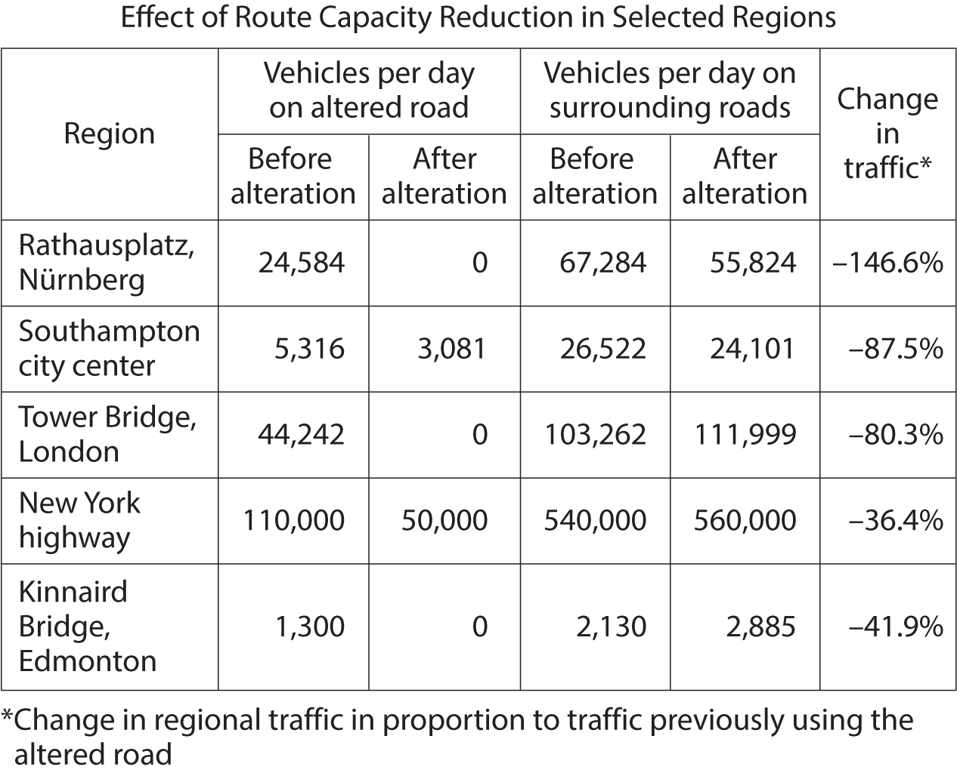

Begin skippable figure description.
Figure 1 presents a 6 column table titled “Effect of Route Capacity Reduction in Selected Regions.” The heading for column 1 is “Region.” The heading for columns 2 and 3 is “Vehicles per day on altered road.” The subheading for column 2 is “Before alteration,” and the subheading for column 3 is “After alteration.” The heading for columns 4 and 5 is “Vehicles per day on surrounding roads.” The subheading for column 4 is “Before alteration,” and the subheading for column 5 is “After alteration.” And the heading for column 6 is “Change in traffic.” A note for column 6 indicates that “Change in regional traffic in proportion to traffic previously using the altered road.” There are 5 rows of data in the table. The data are as follows.

Region, Rathausplatz, Nürnberg. Vehicles per day on altered road: Before alteration, 24,584; After alteration, 0. Vehicles per day on surrounding roads: Before alteration, 67,284; After alteration, 55,824. Change in traffic, negative 146.6%.
Region, Southampton city center. Vehicles per day on altered road: Before alteration, 5,316; After alteration, 3,081. Vehicles per day on surrounding roads: Before alteration, 26,522; After alteration, 24,101. Change in traffic, negative 87.5%.
Region, Tower Bridge, London. Vehicles per day on altered road: Before alteration, 44,242; After alteration, 0. Vehicles per day on surrounding roads: Before alteration, 103,262; After alteration, 111,999. Change in traffic, negative 80.3%.
Region, New York highway. Vehicles per day on altered road: Before alteration, 110,000; After alteration, 50,000. Vehicles per day on surrounding roads: Before alteration, 540,000; After alteration, 560,000. Change in traffic, negative 36.4%.
Region, Kinnaird Bridge, Edmonton. Vehicles per day on altered road: Before alteration, 1,300; After alteration, 0. Vehicles per day on surrounding roads: Before alteration, 2,130; After alteration, 2,885. Change in traffic, negative 41.9%.

End skippable figure description.

Figure 2
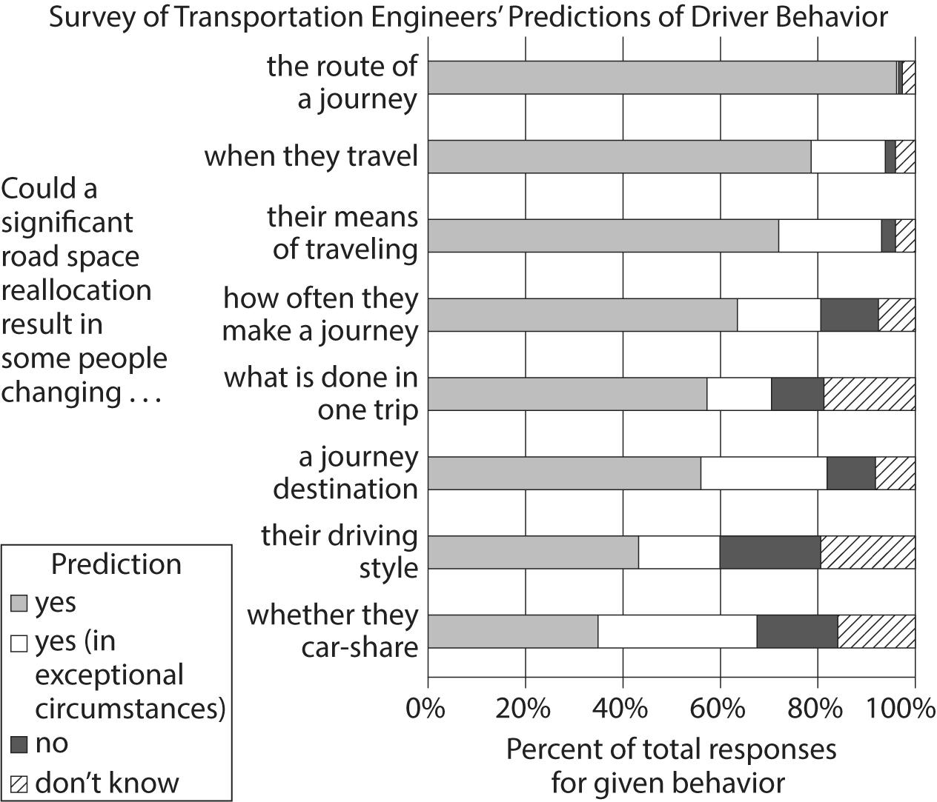

Begin skippable figure description.
Figure 2 presents a horizontal stacked bar graph titled “Survey of Transportation Engineers’ Predictions of Driver Behavior.” The horizontal axis is labeled “Percent of total responses for given behavior,” and the percentages 0 through 100, in increments of 20 percent, are indicated. The vertical axis is labeled “Could a significant road space reallocation result in some people changing, dot dot dot” and 8 categories are indicated along the axis. The name of each category completes the vertical axis label. A bar is given for each category. The bars are each divided into 4 sections that add up to 100 percent. A key indicates that the sections represent the following predictions: “yes,” “yes, in exceptional circumstances,” “no,” and “don’t know.” The data for each category are as follows. Note that all values are approximate.

Category 1. Could a significant road space reallocation result in some people changing the route of a journey. Yes, 96%. Yes, in exceptional circumstances, 0.5%. No, 1%. Don’t know, 2.5%.
Category 2. Could a significant road space reallocation result in some people changing when they travel. Yes, 78%. Yes, in exceptional circumstances, 16%. No, 2%. Don’t know, 4%.
Category 3. Could a significant road space reallocation result in some people changing their means of traveling. Yes, 72%. Yes, in exceptional circumstances, 21%. No, 3%. Don’t know, 4%.
Category 4. Could a significant road space reallocation result in some people changing how often they make a journey. Yes, 64%. Yes, in exceptional circumstances, 15%. No, 13.5%. Don’t know, 7.5%.
Category 5. Could a significant road space reallocation result in some people changing what is done in one trip. Yes, 57.5%. Yes, in exceptional circumstances, 11.5%. No, 12%. Don’t know, 19%.
Category 6. Could a significant road space reallocation result in some people changing a journey destination. Yes, 56%. Yes, in exceptional circumstances, 26%. No, 10%. Don’t know, 8%.
Category 7. Could a significant road space reallocation result in some people changing their driving style. Yes, 43.5%. Yes, in exceptional circumstances, 16%. No, 21%. Don’t know, 19.5%.
Category 8. Could a significant road space reallocation result in some people changing whether they car-share. Yes, 35%. Yes, in exceptional circumstances, 32%. No, 17%. Don’t know, 16%.

End skippable figure description.

Figures adapted from S. Cairns and others, “Disappearing Traffic? The Story So Far.” ©2002 by U C L.

Question 11.
The main purpose of the passage is to
A. provide support for the claim that efforts to reduce traffic actually increase traffic.
B. dispute the widely held belief that building and improving mass transit systems is good for the environment.
C. discuss the negative environmental consequences of car-focused development and suburban sprawl.
D. argue that one way to reduce the negative environmental effects of traffic is to make driving less agreeable.

Question 12.
Which choice best supports the idea that the author assumes that, all things being equal, people would rather drive than take mass transit?
A. Sentence 1 of paragraph 1 (“Building . . . car”)
B. Sentence 2 of paragraph 1 (“To have . . . overall”)
C. Sentence 5 of paragraph 1 (“But they’re . . . productive”)
D. Sentence 1 of paragraph 2 (“One . . . commutes”)

Question 13.
As used in sentence 3 of paragraph 1, the phrase “backed up” most nearly means
A. supported.
B. copied.
C. substituted.
D. jammed.

Question 14.
In paragraph 1, the author concedes that his recommendations are
A. costly to implement.
B. not widely supported.
C. strongly opposed by experts.
D. environmentally harmful in the short term.

Question 15.
Based on the passage, how would the author most likely characterize many attempts to improve traffic?
A. They are doomed to fail because most people like driving too much to change their habits.
B. They overestimate how tolerant people are of long commutes.
C. They are well intentioned but ultimately lead to environmental harm.
D. They will only work if they make driving more economical and productive.

Question 16.
Which choice provides the best evidence for the answer to question 15?
A. Sentence 3 of paragraph 1 (“That . . . tolls”)
B. Sentence 2 of paragraph 2 (“That . . . enough”)
C. The first part of sentence 4 of paragraph 2 (“If, in . . . worse”)
D. Sentence 5 of paragraph 3 (“Moving . . . use”)

Question 17.
According to the passage, reducing commuting time for drivers can have which of the following effects?
A. Drivers become more productive employees than they previously were.
B. Mass transit gets extended farther into suburban areas than it previously was.
C. Mass transit carries fewer passengers and receives less government funding than it previously did.
D. Drivers become more willing to live farther from their places of employment than they previously were.

Question 18.
As used in sentence 2 of paragraph 4, the word “promotes” most nearly means
A. upgrades.
B. serves.
C. advocates.
D. develops.

Question 19.
According to figure 1, how many vehicles traveled on the altered road through the Southampton city center per day before the route was altered?
A. 3,081
B. 5,316
C. 24,101
D. 26,522

Question 20.
Do the data in figure 1 support or weaken the argument of the author of the passage, and why?
A. Support, because the data show that merely moving drivers out of cars can induce traffic.
B. Support, because the data show that reducing road capacity can lead to a net reduction in traffic.
C. Weaken, because the data show that in some cases road alterations lead to greater traffic on surrounding roads.
D. Weaken, because the data show that traffic reductions due to road alterations tend to be brief.

Question 21.
Based on figure 2, the engineers surveyed were most skeptical of the idea that in the event of a reallocation of road space, drivers would change
A. when they travel.
B. their means of traveling.
C. how often they make a journey.
D. their driving style.

Questions 22 through 32 are based on the following passage.
This passage is adapted from Sabrina Richards, “Pleasant to the Touch.” ©2012 by The Scientist.

In the early nineteen nineties, textbooks acknowledged that humans had slow-conducting nerves, but asserted that those nerves only responded to two types of stimuli: pain and temperature. Sensations of pressure and vibration were believed to travel only along myelinated, fast-signaling nerve fibers, which also give information about location. Experiments blocking nerve fibers supported this notion. Preventing fast fibers from firing (either by clamping the relevant nerve or by injecting the local anesthetic lidocaine) seemed to eliminate the sensation of pressure altogether, but blocking slow fibers only seemed to reduce sensitivity to warmth or a small painful shock.

Håkan Olausson and his Gothenburg University colleagues Åke Vallbo and Johan Wessberg wondered if slow fibers responsive to gentle pressure might be active in humans as well as in other mammals. In 1993, they corralled 28 young volunteers and recorded nerve signals while gently brushing the subjects’ arms with their fingertips. Using a technique called microneurography, in which a fine filament is inserted into a single nerve to capture its electrical impulses, the scientists were able to measure how quickly—or slowly—the nerves fired. They showed that soft stroking prompted two different signals, one immediate and one delayed. The delay, Olausson explains, means that the signal from a gentle touch on the forearm will reach the brain about a half second later. This delay identified nerve impulses traveling at speeds characteristic of slow, unmyelinated fibers—about 1 meter per second—confirming the presence of these fibers in human hairy skin. (In contrast, fast-conducting fibers, already known to respond to touch, signal at a rate between 35 and 75 meters per second.)

Then, in 1999, the group looked more closely at the characteristics of the slow fibers. They named these “low-threshold” nerves “C-tactile,” or C T, fibers, said Olausson, because of their “exquisite sensitivity” to slow, gentle tactile stimulation, but unresponsiveness to noxious stimuli like pinpricks.

But why exactly humans might have such fibers, which respond only to a narrow range of rather subtle stimuli, was initially mystifying. Unlike other types of sensory nerves, C T fibers could be found only in hairy human skin—such as the forearm and thigh. No amount of gentle stroking of hairless skin, such as the palms and soles of the feet, prompted similar activity signatures. Olausson and his colleagues decided that these fibers must be conveying a different dimension of sensory information than fast-conducting fibers.

Although microneurography can give information about how a single nerve responds to gentle brushing and pressure, it cannot tease out what aspect of sensation that fiber relays, says Olausson. He wanted to know if that same slow nerve can distinguish where the brush touches the arm, and whether it can discern the difference between a goat-hair brush and a feather. Most importantly, could that same fiber convey a pleasant sensation?

To address the question, Olausson’s group sought out a patient known as G. L. who had an unusual nerve defect. More than 2 decades earlier, she had developed numbness across many parts of her body after taking penicillin to treat a cough and fever. Testing showed that she had lost responsiveness to pressure, and a nerve biopsy confirmed that G. L.’s quick-conducting fibers were gone, resulting in an inability to sense any pokes, prods, or pinpricks below her nose. But she could still sense warmth, suggesting that her slow-conducting unmyelinated fibers were intact.

Upon recruiting G. L., Olausson tested her by brushing her arm gently at the speed of between 2 to 10 centimeters per second. She had more trouble distinguishing the direction or pressure of the brush strokes than most subjects, but reported feeling a pleasant sensation. When the researchers tried brushing her palm, where C T fibers are not found, she felt nothing.

Olausson used functional M R I studies to examine which areas of the brain lit up when G. L.’s arm was gently brushed to activate C T fibers. In normal subjects, both the somatosensory and insular cortices were activated, but only the insular cortex [which processes emotion] was active when researchers brushed G. L.’s arm. This solidified the notion that C T fibers convey a more emotional quality of touch, rather than the conscious aspect that helps us describe what we are sensing. C T fibers, it seemed, specifically provide pleasurable sensations.

Question 22.
Based on the passage, textbook authors in the early nineteen nineties would most likely have expected which condition to result from the blocking of fast fibers?
A. The rate at which other nerve fibers fired would increase.
B. The test subject would perceive gentle stimuli as painful.
C. The body would compensate by using slow fibers to sense pressure.
D. The ability to perceive vibrations would be impaired.

Question 23.
Which choice provides the best evidence for the answer to question 22?
A. Sentence 1 of paragraph 1 (“In the . . . temperature”)
B. Sentence 2 of paragraph 1 (“Sensations . . . location”)
C. The last part of sentence 4 of paragraph 1 (“blocking . . . shock”)
D. Sentence 7 of paragraph 2 (“In contrast . . . 75 meters per second”)

Question 24.
As used in sentence 1 of paragraph 2, the word “active” most nearly means
A. present.
B. attentive.
C. movable.
D. restless.

Question 25.
As used in sentence 3 of paragraph 2, the word “capture” most nearly means
A. occupy.
B. seize.
C. record.
D. influence.

Question 26.
Which conclusion is best supported by the findings of Olausson’s 1993 experiment?
A. Stimulation at bodily extremities can be sensed as rapidly as stimulation closer to the brain.
B. The presence of hairs in human skin lessens the speed with which nerves conduct signals.
C. Gentle pressure is sensed not only by fast fibers but also by slow fibers.
D. The speed at which a nerve fires is dependent on the strength of pressure applied to the nerve.

Question 27.
Which choice provides the best evidence for the answer to question 26?
A. Sentence 3 of paragraph 2 (“Using . . . fired”)
B. Sentence 4 of paragraph 2 (“They . . . delayed”)
C. Sentence 5 of paragraph 2 (“The delay . . . later”)
D. Sentence 1 of paragraph 3 (“Then . . . fibers”)

Question 28.
Sentence 1 in paragraph 4 (“But . . . mystifying”) serves mainly to
A. identify factors that Olausson had previously failed to consider.
B. propose a solution to a dilemma encountered by Olausson.
C. anticipate a potential criticism of Olausson by the reader.
D. show a problem from the perspective of Olausson’s team.

Question 29.
It can reasonably be inferred that one of the intended goals of the 1999 experiment was to determine the
A. precise nature of sensations that C T fibers can convey.
B. relationship between body hair and C T fiber function.
C. role played by C T fibers in the perception of pain.
D. effect of microneurography on C T fiber signaling.

Question 30.
The main purpose of paragraph 6 is to
A. identify those of G. L.’s neurological conditions that might be relieved by the experiment.
B. contextualize the nerve function of G. L. by comparing it with that of other adults.
C. detail procedures that G. L. had experienced during previous experiments.
D. indicate why G. L.’s medical condition was of value to Olausson’s experiment.

Question 31.
According to the passage, G. L. differed from Olausson’s other test subjects in terms of the
A. number of cortices activated in the brain during gentle brushing.
B. physical dimensions of the somatosensory cortex.
C. intensity of nerve signals required to activate the insular cortex.
D. effect of M R I scanning on the basic function of brain cortices.

Question 32.
According to the passage, humans experience an emotional aspect of touch when
A. brain cortices are shielded from nerve signals.
B. C T fibers are exposed to a stimulus.
C. nerve fibers that sense pain are suppressed.
D. conscious aspects of sensation are ignored.

Questions 33 through 42 are based on the following passages.
Passage 1 is adapted from a speech delivered in 1898 by Albert J. Beveridge, “March of the Flag.” Passage 2 is adapted from a speech delivered in 1900 by William Jennings Bryan, “Imperialism.”

Passage 1.
Fellow-Citizens: It is a noble land that God has given us; a land that can feed and clothe the world; a land whose coast lines would enclose half the countries of Europe; a land set like a sentinel between the two imperial oceans of the globe; a greater England with a nobler destiny. It is a mighty people that He has planted on this soil; a people sprung from the most masterful blood of history; a people perpetually revitalized by the virile . . . working-folk of all the earth; a people imperial by virtue of their power, by right of their institutions, by authority of their heaven-directed purposes—the propagandists and not the misers of liberty. It is a glorious history our God has bestowed upon His chosen people; a history whose keynote was struck by Liberty Bell; a history heroic with faith in our mission and our future; a history of statesmen, who flung the boundaries of the Republic out into unexplored lands . . . a history of soldiers, who carried the flag across blazing deserts and through the ranks of hostile mountains, even to the gates of sunset; a history of a multiplying people, who overran a continent in half a century . . . a history divinely logical, in the process of whose tremendous reasoning we find ourselves to-day. . . .

Think of the thousands of Americans who will pour into Hawaii and Porto Rico when the Republic’s laws cover those islands with justice and safety! Think of the tens of thousands of Americans who will invade . . . the Philippines when a liberal government . . . shall establish order and equity there! Think of the hundreds of thousands of Americans who will build a . . . civilization of energy and industry in Cuba, when a government of law replaces the double reign of anarchy and tyranny!—think of the prosperous millions that Empress of Islands will support when, obedient to the law of political gravitation, her people ask for the highest honor liberty can bestow, the sacred Order of the Stars and Stripes, the citizenship of the Great Republic!

Passage 2.
If it is right for the United States to hold the Philippine Islands permanently and imitate European empires in the government of colonies, the Republican party ought to state its position and defend it, but it must expect the subject races to protest against such a policy and to resist to the extent of their ability.

The Filipinos do not need any encouragement from Americans now living. Our whole history has been an encouragement not only to the Filipinos, but to all who are denied a voice in their own government. If the Republicans are prepared to censure all who have used language calculated to make the Filipinos hate foreign domination, let them condemn the speech of Patrick Henry. When he uttered that passionate appeal, “Give me liberty or give me death,” he exprest a sentiment which still echoes in the hearts of men.

Let them censure Jefferson; of all the statesmen of history none have used words so offensive to those who would hold their fellows in political bondage. Let them censure Washington, who declared that the colonists must choose between liberty and slavery. Or, if the statute of limitations has run against the sins of Henry and Jefferson and Washington, let them censure Lincoln, whose Gettysburg speech will be quoted in defense of popular government when the present advocates of force and conquest are forgotten.

Some one has said that a truth once spoken can never be recalled. It goes on and on, and no one can set a limit to its ever-widening influence. But if it were possible to obliterate every word written or spoken in defense of the principles set forth in the Declaration of Independence, a war of conquest would still leave its legacy of perpetual hatred, for it was God himself who placed in every human heart the love of liberty. He never made a race of people so low in the scale of civilization or intelligence that it would welcome a foreign master.

Those who would have this Nation enter upon a career of empire must consider, not only the effect of imperialism on the Filipinos, but they must also calculate its effects upon our own nation. We cannot repudiate the principle of self-government in the Philippines without weakening that principle here.

Question 33.
In Passage 1, Beveridge asserts that the resources and immensity of the United States constitute a
A. safeguard against foreign invasion.
B. replication of conditions in Europe.
C. divine gift to the American people.
D. source of envy for people in other countries.

Question 34.
In paragraph 2 of Passage 1, the commands given by Beveridge mainly serve to
A. remind the audience of its civic responsibilities.
B. anticipate the benefits of a proposed policy.
C. emphasize the urgency of a national problem.
D. refute arguments that opponents have advanced.

Question 35.
As used in sentence 1 of paragraph 6, the word “recalled” most nearly means
A. repeated.
B. retracted.
C. rejected.
D. remembered.

Question 36.
It can reasonably be inferred from Passage 2 that Bryan considers the preference for national sovereignty over foreign rule to be a
A. reaction to the excesses of imperial governments in the modern era.
B. sign that the belief in human equality is widespread.
C. testament to the effects of the foreign policy of the United States.
D. manifestation of an innate drive in humans toward self-rule.

Question 37.
Which choice provides the best evidence for the answer to question 36?
A. Sentence 3 of paragraph 4 (“If the . . . Henry”)
B. Sentence 2 of paragraph 6 (“It goes . . . influence”)
C. Sentence 4 of paragraph 6 (“He never . . . master”)
D. Sentence 1 of paragraph 7 (“Those . . . nation”)

Question 38.
As used in sentence 1 of paragraph 7, the word “calculate” most nearly means
A. evaluate.
B. design.
C. assume.
D. multiply.

Question 39.
In developing their respective arguments, Beveridge (Passage 1) and Bryan (Passage 2) both express admiration for the
A. founding and history of the United States.
B. vibrancy and diversity of American culture.
C. worldwide history of struggles for independence.
D. idealism that permeates many aspects of American society.

Question 40.
Which choice best describes a central difference between how Beveridge (Passage 1) and Bryan (Passage 2) view the concept of liberty as it is realized in the United States?
A. Beveridge presents it as the direct inheritance of European colonization, whereas Bryan presents it as a sharp break from earlier governments in Europe.
B. Beveridge considers it so exemplary as to justify conquest of other regions, whereas Bryan warns that its exemplary quality would be undermined by imperial expansion.
C. Beveridge argues that it arose organically as the United States matured, whereas Bryan argues that it was present from the country’s beginnings.
D. Beveridge regards it as a model that should be shared with other countries, whereas Bryan believes that it is unique to the United States and could not work elsewhere.

Question 41.
It can most reasonably be inferred from Passage 2 that Bryan would criticize the vision of American governance of island territories that Beveridge presents in Passage 1 for being
A. unrealistic, since most Americans would be unwilling to relocate to distant islands.
B. deceptive, since economic domination would be the true goal of the American government.
C. impractical, since the islanders would insist upon an equal distribution of resources.
D. naive, since the islanders would object to being governed by Americans.

Question 42.
Which choice from Passage 2 provides the best evidence for the answer to question 41?
A. Sentence 1 of paragraph 3 (“If it . . . ability”)
B. Sentence 1 of paragraph 4 (“The Filipinos . . . living”)
C. Sentence 2 of paragraph 4 (“Our . . . government”)
D. Sentence 4 of paragraph 4 (“When . . . men”)

Questions 43 through 52 are based on the following passage and supplementary material.
This passage is adapted from Peter A. Ensminger, Life Under the Sun. ©2001 by Peter A. Ensminger.

Many millennia before the invention of herbicides, farmers simply plowed their fields to control weeds. Even today, plowing can constitute a valuable part of an integrated weed-management program. Although plowing kills standing weeds, farmers have long known that it often leads to the emergence of new weed seedlings in a few weeks.

Ecologists have shown that a farmer’s field can have 50,000 or more weed seeds per square meter buried beneath the soil surface. Plant physiologists have shown that seeds buried more than about one centimeter below the soil surface do not receive enough light to germinate. Do the blades of a plow, which can reach more than a foot beneath the soil surface, bring some of these buried seeds to the surface where their germination is induced by exposure to sunlight?

Two ecologists, Jonathan Sauer and Gwendolyn Struik, began to study this question in the nineteen sixties. In a relatively simple experiment, they went to ten different habitats in Wisconsin during the night and collected pairs of soil samples. They stirred up the soil in one sample of each pair in the light and stirred up the other sample of each pair in the dark. They then exposed all ten pairs to natural sunlight in a greenhouse. For nine of the ten pairs of soil samples, weed growth was greater in the samples stirred up in light. They concluded that soil disturbance gives weed seeds a “light break,” and this stimulates their germination.

More recently, Karl Hartmann of Erlangen University in Germany reasoned that when farmers plowed their fields during the day, the buried weed seeds are briefly exposed to sunlight as the soil is turned over, and that this stimulates their germination. Although the light exposures from plowing may be less than one millisecond, that can be enough to induce seed germination. Thus the germination of weed seeds would be minimized if farmers simply plowed their fields during the night, when the photon fluence rate [the rate at which photons hit the surface] is below 10 to the fifteenth power photons per square meter per second. Although even under these conditions hundreds of millions of photons strike each square millimeter of ground each second, this illumination is below the threshold needed to stimulate the germination of most seeds.

Hartmann says that he was very skeptical when he first came up with this idea because he assumed that such a simple method of weed control as plowing at nighttime must be ineffective or it would have been discovered long ago. But the subsequent experiments, first presented at a 1989 scientific meeting in Freiburg, Germany, clearly demonstrated that the method can be effective.

Hartmann tested his idea by plowing two agricultural strips near Altershausen, Germany. The farmer Karl Seydel cultivated one strip, repeated threefold, at around midday and the other strip at night. No crops were planted in these pilot experiments, to avoid possible competition with the emerging weeds. The results were dramatic. More than 80 percent of the surface of the field plowed in daylight was covered by weeds, whereas only about 2 percent of the field plowed at night was covered by weeds.

This method of weed control is currently being used by several farmers in Germany. Because many of the same weed species that invade farmers’ fields in Germany also invade fields elsewhere in the world, this method should be successful elsewhere. In fact, recent studies at universities in Nebraska, Oregon, Minnesota, Denmark, Sweden, and Argentina support this idea.

Note: The following table supplements this passage.
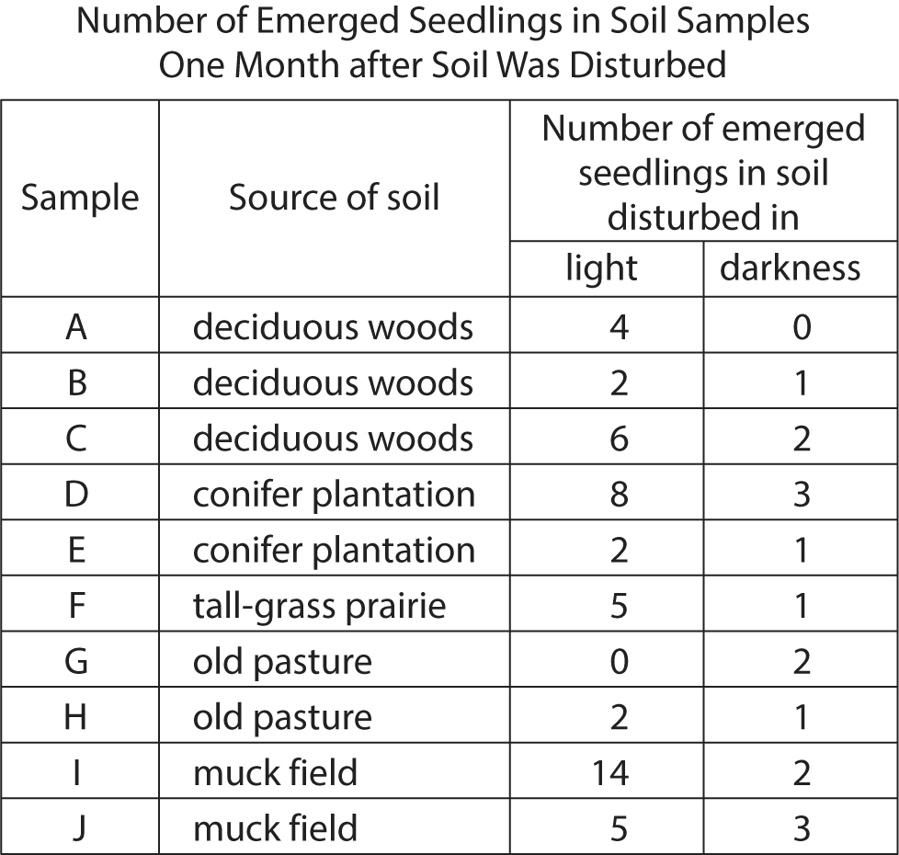

Begin skippable figure description.
The figure presents a 4 column table titled “Number of Emerged Seedlings in Soil Samples One Month after Soil Was Disturbed.” The heading for column 1 is “Sample.” The heading for column 2 is “Source of soil.” And the heading for columns 3 and 4 is “Number of emerged seedlings in soil disturbed in . . .” The subheading for column 3 is “light,” and the subheading for column 4 is “darkness.” There are 10 rows of data in the table. The data are as follows.

Sample A. Source of soil, deciduous woods. Number of emerged seedlings in soil disturbed in light, 4. Number of emerged seedlings in soil disturbed in darkness, 0.
Sample B. Source of soil, deciduous woods. Number of emerged seedlings in soil disturbed in light, 2. Number of emerged seedlings in soil disturbed in darkness, 1.
Sample C. Source of soil, deciduous woods. Number of emerged seedlings in soil disturbed in light, 6. Number of emerged seedlings in soil disturbed in darkness, 2.
Sample D. Source of soil, conifer plantation. Number of emerged seedlings in soil disturbed in light, 8. Number of emerged seedlings in soil disturbed in darkness, 3.
Sample E. Source of soil, conifer plantation. Number of emerged seedlings in soil disturbed in light, 2. Number of emerged seedlings in soil disturbed in darkness, 1.
Sample F. Source of soil, tall-grass prairie. Number of emerged seedlings in soil disturbed in light, 5. Number of emerged seedlings in soil disturbed in darkness, 1.
Sample G. Source of soil, old pasture. Number of emerged seedlings in soil disturbed in light, 0. Number of emerged seedlings in soil disturbed in darkness, 2.
Sample H. Source of soil, old pasture. Number of emerged seedlings in soil disturbed in light, 2. Number of emerged seedlings in soil disturbed in darkness, 1.
Sample I. Source of soil, muck field. Number of emerged seedlings in soil disturbed in light, 14. Number of emerged seedlings in soil disturbed in darkness, 2.
Sample J. Source of soil, muck field. Number of emerged seedlings in soil disturbed in light, 5. Number of emerged seedlings in soil disturbed in darkness, 3.

End skippable figure description.

Adapted from Jonathan Sauer and Gwendolyn Struik, “A Possible Ecological Relation between Soil Disturbance, Light-Flash, and Seed Germination.” ©1964 by Jonathan Sauer and Gwendolyn Struik.

Question 43.
According to the passage, exposure to light allows seeds to
A. begin to develop.
B. absorb necessary nutrients.
C. withstand extreme temperatures.
D. achieve maximum growth.

Question 44.
The question in paragraph 2 primarily serves to
A. emphasize the provisional nature of the findings discussed in the passage.
B. introduce the specific research topic addressed in the passage.
C. suggest the hypothetical impact of the studies analyzed in the passage.
D. indicate the level of disagreement about the methods explored in the passage.

Question 45.
As used in sentence 3 of paragraph 2, the word “induced” most nearly means
A. lured.
B. established.
C. convinced.
D. stimulated.

Question 46.
Which choice best supports the idea that seeds present in fields plowed at night are exposed to some amount of light?
A. Sentence 1 of paragraph 4 (“More . . . germination”)
B. Sentence 2 of paragraph 4 (“Although . . . germination”)
C. Sentence 4 of paragraph 4 (“Although . . . seeds”)
D. Sentence 1 of paragraph 5 (“Hartmann . . . ago”)

Question 47.
The passage suggests that if Seydel had planted wheat or corn on the two agricultural strips in Hartmann’s experiment, the percentage of the surface of each strip covered with weeds would likely have been
A. lower than the percentage that Hartmann found.
B. higher than the percentage that Hartmann had predicted.
C. nearly impossible for Hartmann to determine.
D. comparable to Hartmann’s original projection.

Question 48.
Which choice provides the best evidence for the answer to question 47?
A. Sentences 1 and 2 of paragraph 6 (“Hartmann . . . night”)
B. Sentence 3 of paragraph 6 (“No crops . . . weeds”)
C. Sentence 4 of paragraph 6 (“The results . . .dramatic”)
D. Sentence 5 of paragraph 6 (“More . . . weeds”)

Question 49.
As used in sentence 4 of paragraph 6, the word “dramatic” most nearly means
A. theatrical.
B. sudden.
C. impressive.
D. emotional.

Question 50.
According to the table, in which soil sample disturbed in darkness did the fewest number of seedlings emerge?
A. Sample A
B. Sample B
C. Sample C
D. Sample D

Question 51.
As presented in the table, which sample produced the most seedlings when the soil was disturbed in light?
A. Sample G
B. Sample H
C. Sample I
D. Sample J

Question 52.
The data presented in the table most directly support which claim from the passage?
A. Sentence 1 of paragraph 1 (“Many . . . weeds”)
B. Sentence 1 of paragraph 2 (“Ecologists . . . surface”)
C. Sentence 2 of paragraph 2 (“Plant . . . germinate”)
D. Sentence 3 of paragraph 4 (“Thus . . . second”)

Stop.
If you finish before time is called, you may check your work on this section only. Do not go on to any other section.

